# Table of Contents

**Table of Contents 1**

**Executive Summary 2**

**Preprocessing 3**

Initial Analysis 3

Graphical Analysis 5

Data Transformation 20

**Clustering Methods and Results 22**

DBSCAN 28

Fuzzy C-Means 31

**Cluster Qualities 34**

Intra-Cluster Comparison 34

K-Means 34

K=19 34

K=21 37

PAM (Partitioning Around Medoids) 41

K=19 41

K=21 43

DBSCAN 45

Eps = 1.78 45

Eps = 1.34 47

Eps = 0.88 48

Fuzzy-C Means 50

K= 17 50

K = 19 52

K= 21 54

Inter-Cluster Comparison 56

**Cluster Patterns 58**

**Conclusion 68**

# 

# Executive Summary

The presented report is dedicated to taking the reader through a comprehensive discussion of the patterns found based on preprocessing and clustering of the Adult/Census Income dataset.

The first section of the report will discuss the steps taken in preprocessing the data, which is a basic yet indispensable step in data mining. The proposed solution includes a variety of steps including, detecting and handling missing values, one-hot encoding categorical values into appropriate formats, scaling data, dealing with outliers, feature selection via common domain knowledge and random forests, and data transformation using Principal Component Analysis (PCA). The aforementioned processes also required several visualization techniques and the use of sophisticated technology like IBM Watson, which have been documented for the readers’ perusal.

The second segment deals with the multitude of clustering techniques adopted in the proposed solution in a bid to achieve better results. These include models such as k-means, hierarchical, partition around medoids (PAM), density-based spatial clustering of applications with noise (DBSCAN), model-based, and fuzzy c-means clustering. Several heuristics were used to determine the optimal number of clusters, such as the elbow method, within cluster sum of squares, the silhouette method, the gap statistic method, the Dunn Index method, and the ratio of between sum of squares to the total sum of squares.

The third section provides detailed insights about the quality of clusters. The quality was measured and evaluated based on primary quality parameters, which include cluster cohesion, and separation. These pivotal parameters were estimated for the variety of clustering models using the silhouette method, and cluster visualization.

Subsequently, any emergent patterns in the clusters have been analyzed, evaluated, and described. The final segment of the report is a conclusion which encapsulates all key sections and findings of the presented document.

# Preprocessing

## Initial Analysis

On looking at the values of the dataset and some research it was found that the dataset is about the US Adult Census Dataset, and it has been extracted from the 1994 US Census Dataset.

After loading the adult dataset we examined the data using R and IBM Watson and we found that the dataset had some missing values in the form of “ ?”. Upon scrutinizing the number of rows that had different values and trying out different techniques, a decision was made to drop all rows with missing values, which cleaned the dataset and rendered it suitable and for all the clustering and analysis that followed.

In a bid to gain an initial understanding of the dataset, every feature was examined and the following key insights were gained:

age: A numerical feature that refers to the age of the individual, and has integer values above 0.

workclass: A categorical feature that refers to the work status of an individual. It has the following unique values: "Private", "Self-emp-not-inc", "Self-emp-inc", "Federal-gov", "Local-gov", "State-gov", "Without-pay", "Never-worked".

fnlwgt: A numerical feature that refers to the count of people that correspond to the entry as thought about by the census. It has integer values above 0, and it seems like this feature may not be very useful for clustering purposes.

education: An ordinal feature representing the highest education level of the person. It has unique values, "Preschool", "1st-4th", "5th-6th", "7th-8th", "9th", "10th", "11th", "12th", "HS-grad", "Some-college", "Assoc-acdm", "Assoc-voc", "Bachelors", "Masters", "Doctorate", "Prof-school".

education-num: An ordinal feature representing the highest education level of the person in numerical form. This would certainly help in pre-processing and it is apparent that education could be gotten rid of because this feature is simply the representation of the education. It has values greater than 0 up until 16.

marital­-status: A categorical feature representing the current marital status of the person. It has unique values, "Married-civ-spouse", "Divorced", "Never-married", "Separated", "Widowed", "Married-spouse-absent", "Married-AF-spouse". It is very apparent that people with the marital status "Married-civ-spouse", "Married-spouse-absent", and "Married-AF-spouse", can be assigned a single marital status of “Married”.

occupation: A categorical feature representing the occupation of a person. It has unique values, "Tech-support", "Craft-repair", "Other-service", "Sales", "Exec-managerial", "Prof-specialty", "Handlers-cleaners", "Machine-op-inspct", "Adm-clerical", "Farming-fishing", "Transport-moving", "Priv-house-serv", "Protective-serv", "Armed-Forces".

relationship: A categorical feature representing how a person is related to another. It has unique values, "Wife", "Own-child", "Husband", "Not-in-family", "Other-relative", "Unmarried".

race: A categorical feature that refers to the race of a person. It has unique values, "White", "Asian-Pac-Islander", "Amer-Indian-Eskimo", "Other", "Black".

sex: A categorical feature representing the gender of a person. It has unique values, “Male”, “Female”.

capital­-gain: A numerical feature that refers to the profit generated by an individual by the sale of an asset. It has integer values greater than or equal to 0.

capital-­loss: A numerical feature that refers to the loss caused by an individual by the sale of an asset. It has integer values greater than or equal to 0.

hours­-per-­week: A numerical feature that represents the number of hours a person works in a week. It is a continuous value above 0.

native-­country: A categorical feature that refers to the country that a person belongs to. It has unique values, "United-States", "Cambodia", "England", "Puerto-Rico", "Canada", "Germany", "Outlying-US(Guam-USVI-etc)", "India", "Japan", "Greece", "South", "China", "Cuba", "Iran", "Honduras", "Philippines", "Italy", "Poland", "Jamaica", "Vietnam", "Mexico", "Portugal", "Ireland", "France", "Dominican-Republic", "Laos", "Ecuador", "Taiwan", "Haiti", "Columbia", "Hungary", "Guatemala", "Nicaragua", "Scotland", "Thailand", "Yugoslavia", "El-Salvador", "Trinadad&Tobago", "Peru", "Hong", "Holand-Netherlands".

income: A numerical feature representing the annual income of a person. It has values, “<=50k”, and “>50k”.

Following this, the data was visualized in the form of histograms for numerical variables and bar plots for categorical variables, to analyze the distribution of data and look at any interesting emerging patterns. Additionally income distribution was also depicted on the same graphs, in an attempt to look at the various factors affecting the income level of an individual.

## Graphical Analysis

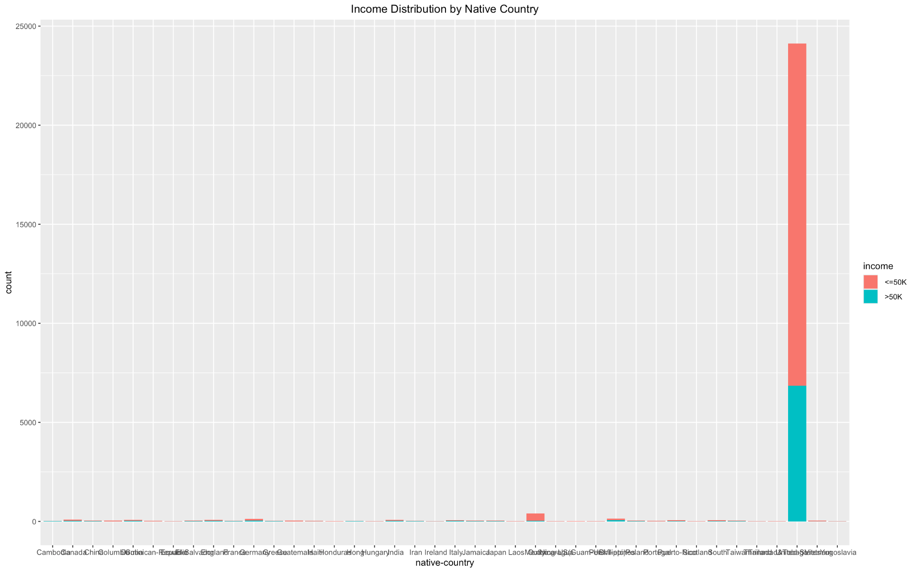

The above graph depicts the distribution of people across different countries and the distribution of income across people originating from different countries. It is very apparent that most of the countries do not constitute a significant fraction of the dataset apart from the United States and therefore the dataset was filtered to find countries that appear more than 2 percent of the time.

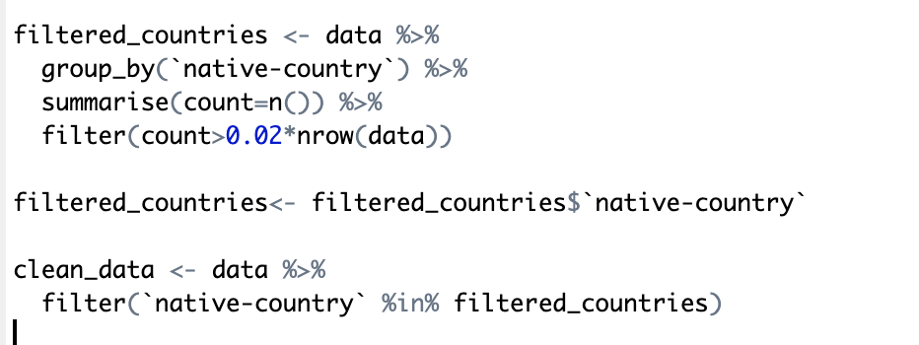

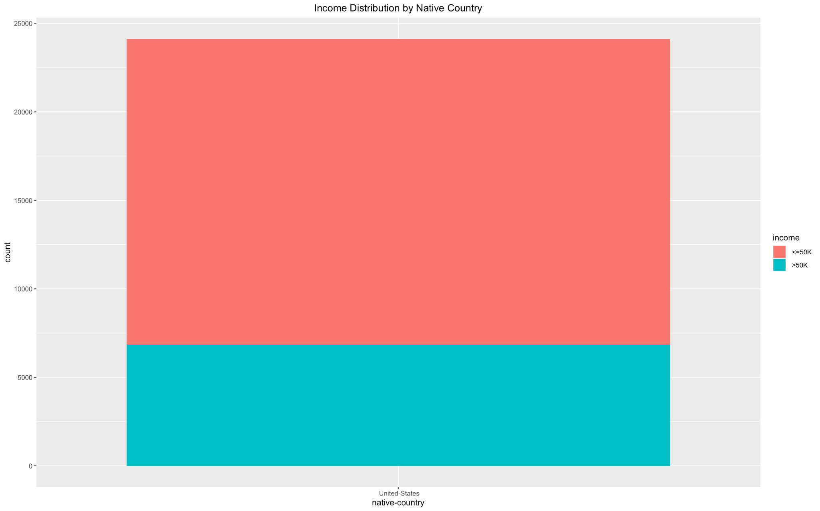

And it was found that only the United States appeared in the dataset more than 2% of the time. In other words roughly the entire dataset is about people originating from the United States. Hence the proposed solution involves filtering out other countries and working mainly with people originating from the United States, which also implies that the feature “native-country” may not be useful for clustering and can be discarded.

Furthermore, It is interesting to note that more than half the population of the dataset earns less than 50K per annum. This is an interesting pattern which could depend on a variety of other factors like number of hours that the individual works per week, the highest education level, the workclass of an individual, but to name a few.

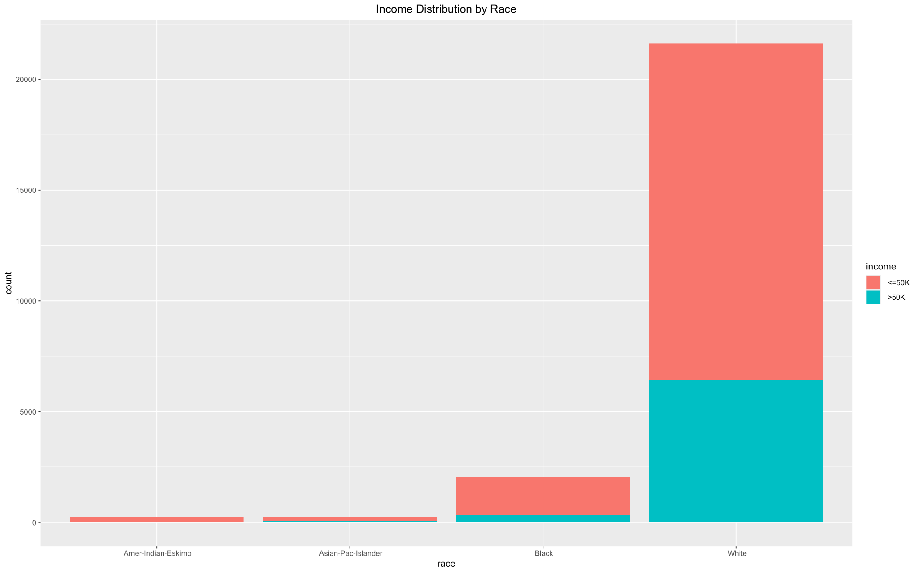

The above graph depicts the distribution of people across different races and the distribution of income across people belonging to those races. It can be readily seen that more than 90 percent of the people belong to the “White” race. In an attempt to generate more interpretable and useful results, the people belonging to classes apart from the race “White” were assigned a single class, “People of Color”. This is because classes with extremely low relative and absolute frequencies, may sometimes be considered as outliers and be ignored or significantly distort clustering results. So combining them could potentially prevent them from being recognized as outliers, and be represented in the analysis in a more generalized form, leading to more meaningful results.

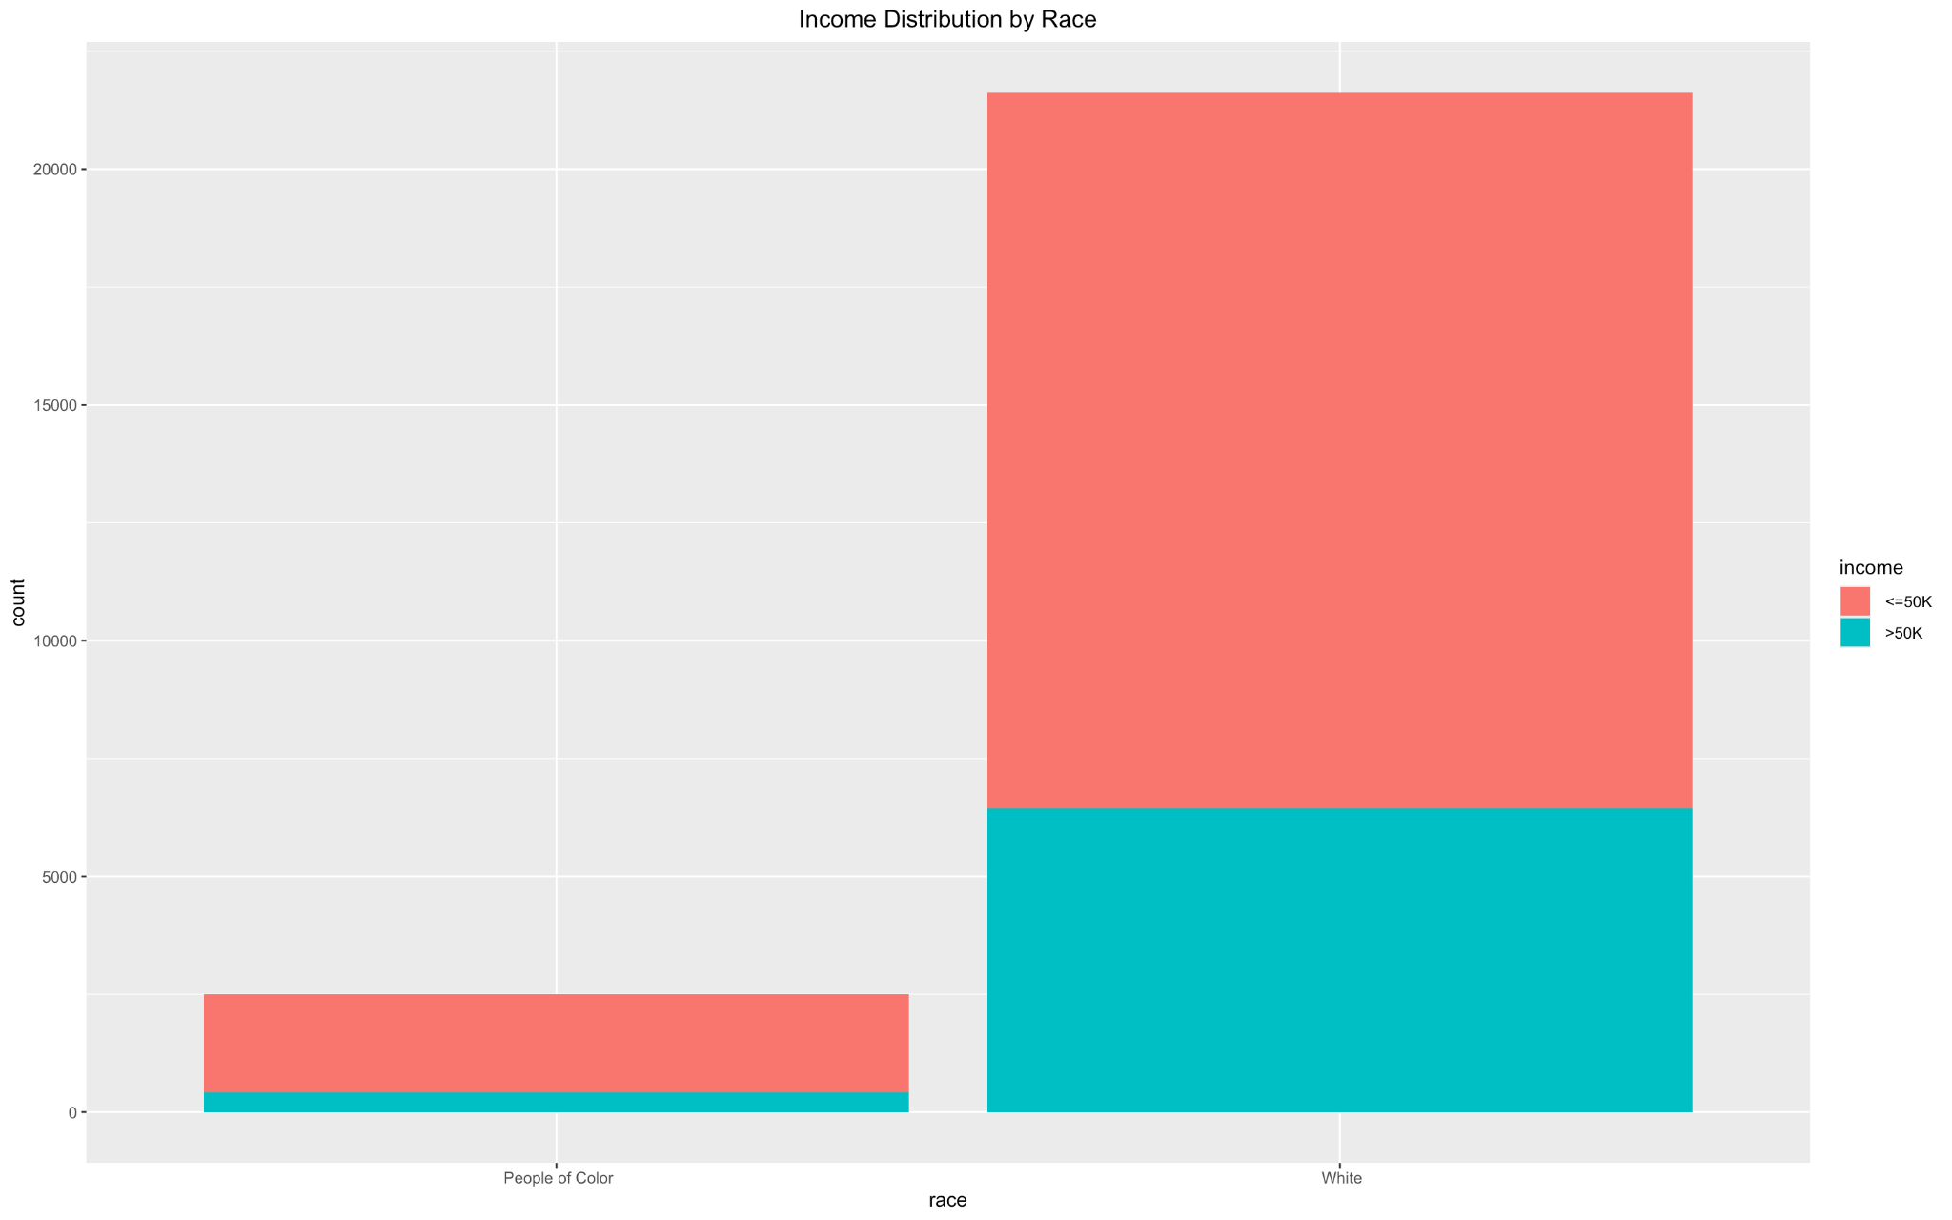

An interesting pattern in the above graph is that people belonging to the ‘White’ race, tend to earn higher than people belonging to other races. So it seems like the dataset is biased towards people belonging to the “White” race. This implies that the feature “race” may prove a distinguishing factor when considering the suitable features for clustering, potentially leading to better quality clusters and streamlined analysis.

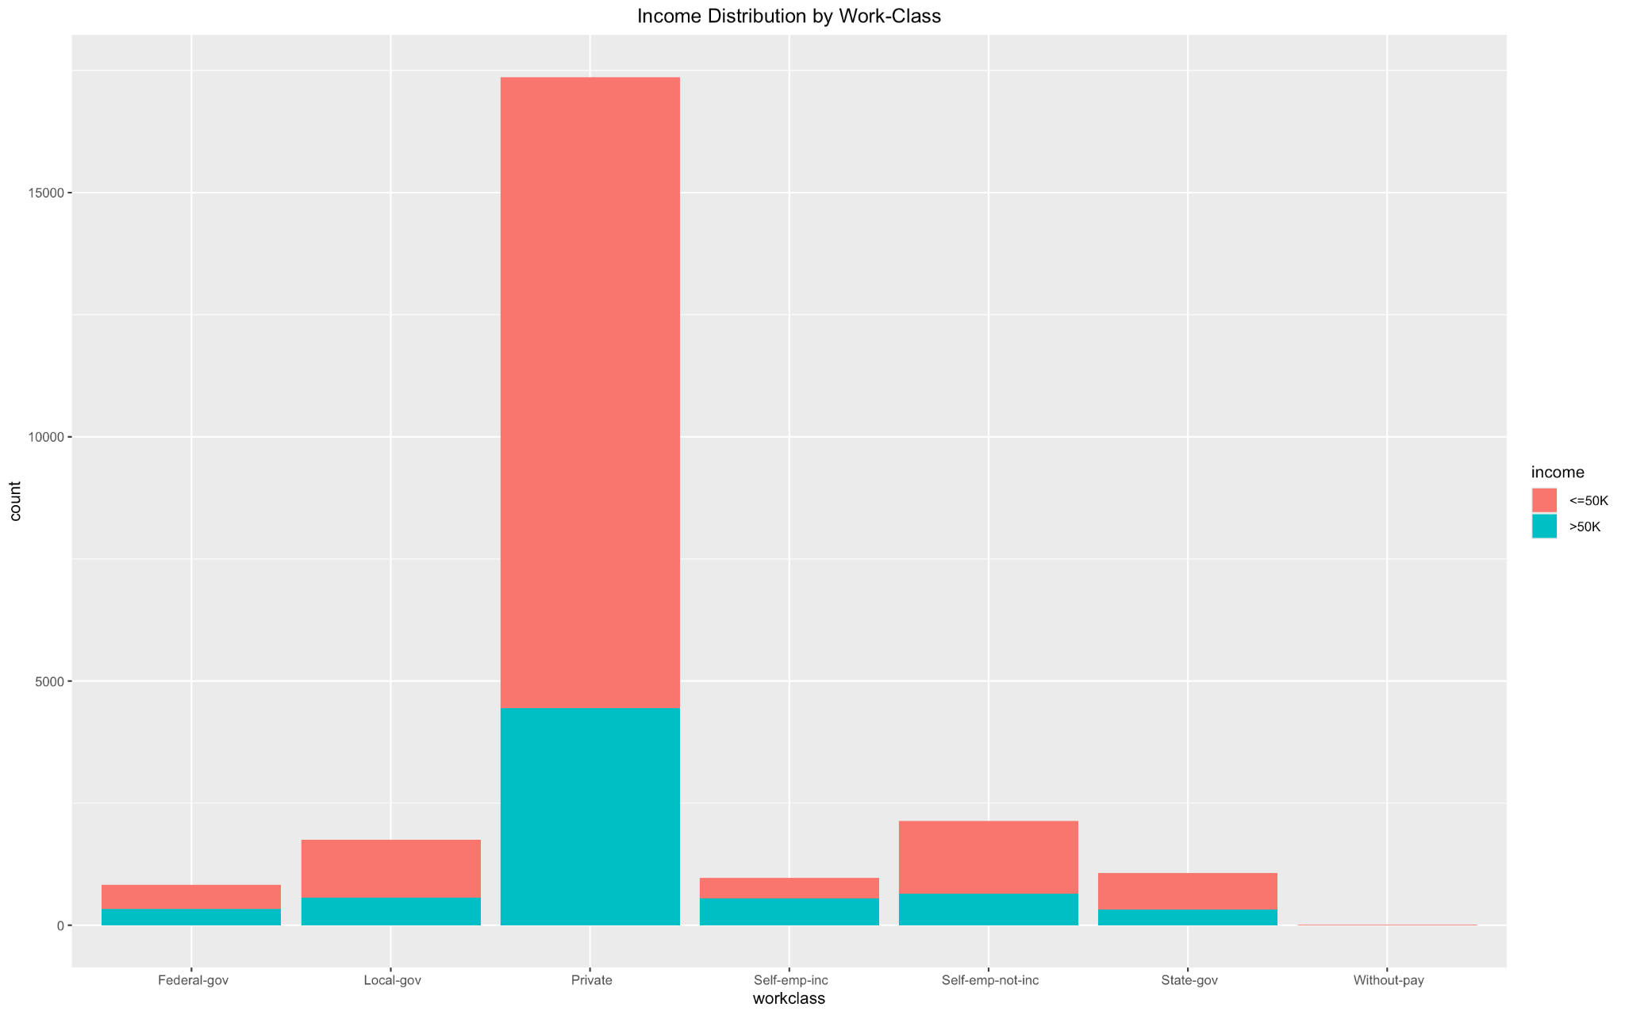

The above graph depicts the distribution of people across different work classes and the distribution of income across people having different work status. Apparently, the majority of the people work in the “Private” sector which is reasonable because of a range of factors, such as more job opportunities, government policies, among others. Moreover, it seems like people who are working without any pay are significant outliers and must be gotten rid of for better cluster analysis. It can be seen that the work status of an individual does not have a significant impact on the income, the distribution is fairly, well balanced, and is representative of the overall pattern in the dataset.

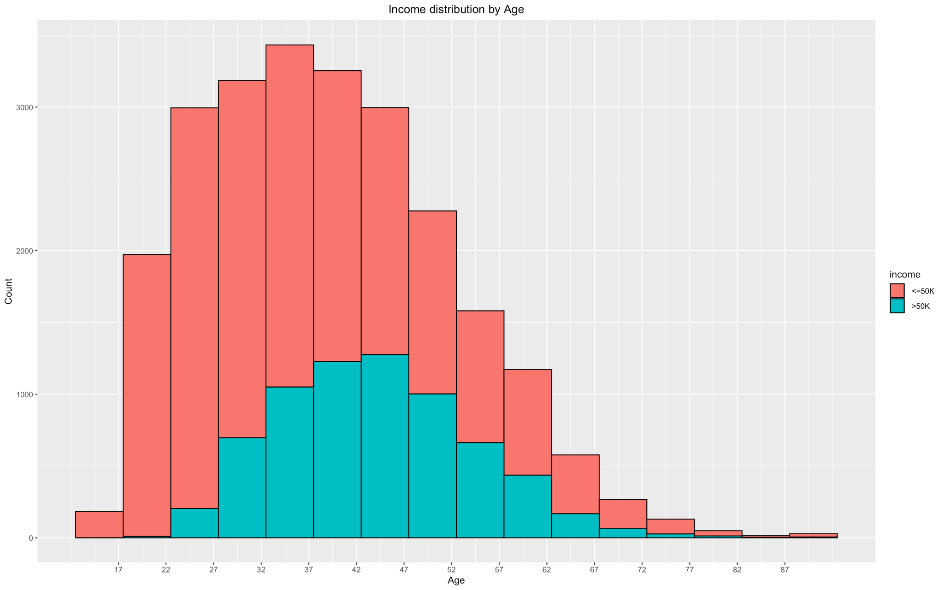

The above graph depicts the distribution of people across different ages and the distribution of income across people having different ages. It can be inferred that as an individual’s age increases the income increases, reaches a peak, and then starts reducing. This pattern is very reasonable, and is expected, because as an individual grows older, they acquire more talent, skills, and experience leading to the corresponding increase in salary. However, once an individual crosses a certain age, their productivity and ability to work for longer hours and more demanding roles decrease which is accompanied by a decrease in income levels. Some of the extreme outliers would be taken care of after z-score scaling or standard scaling, using the threshold of 0.3%.

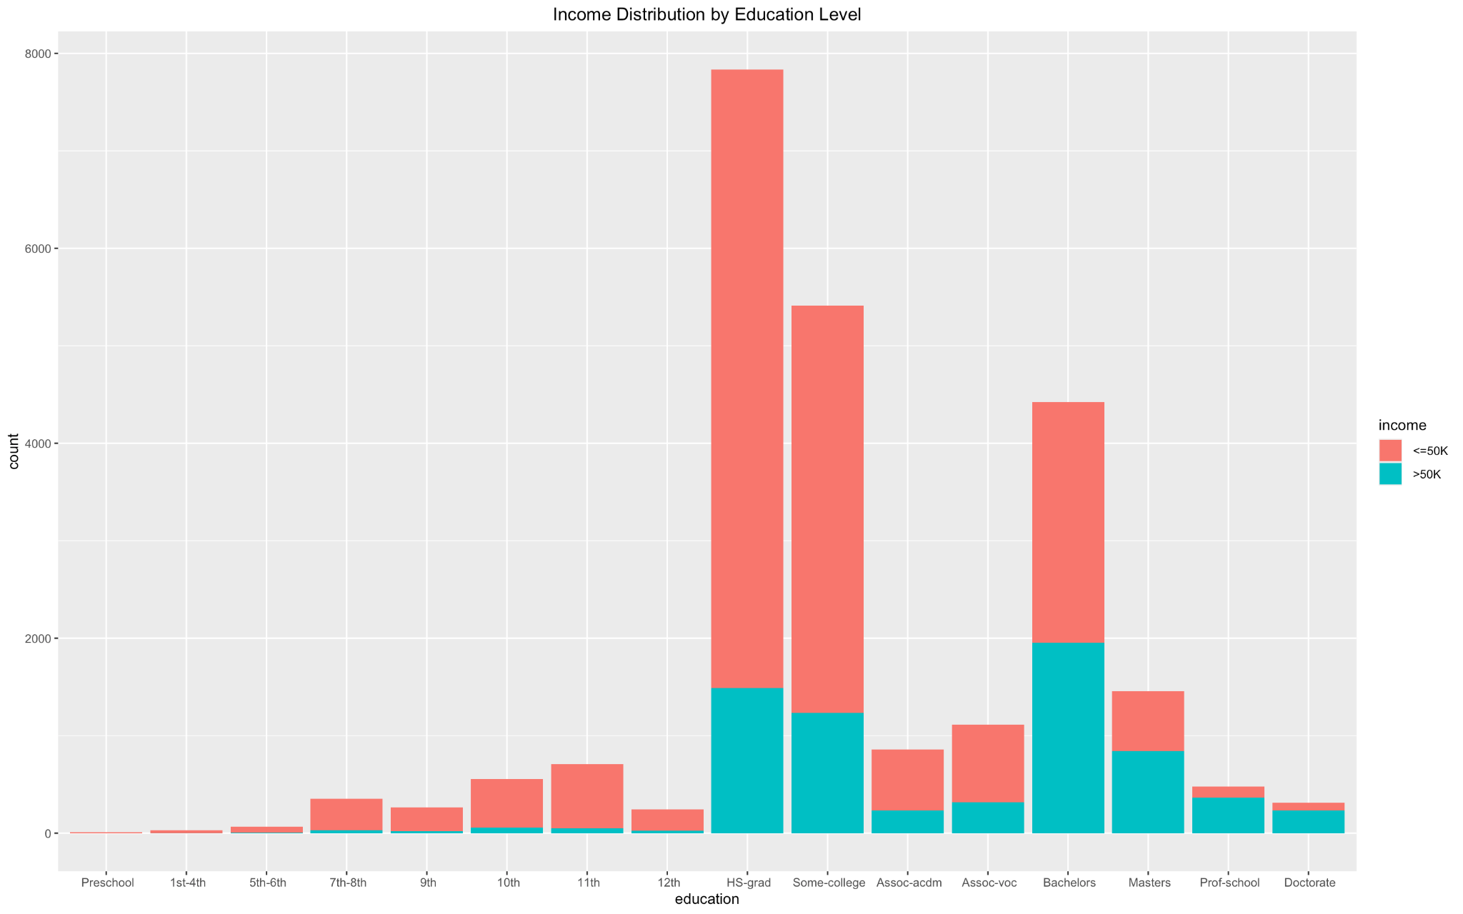

The above graph depicts the distribution of people across different education levels and the distribution of income across people that have attained those education levels. It can be inferred that as an individual’s education level increases the income also increases which is reasonable because as an individual becomes more educated, they acquire more and better skills and contribute better to the workplace. However some interesting patterns emerge, because people with associate degrees earn less than people who have done a high school diploma. Furthermore, it can be seen that people tend to drop out of school after the diploma level, and fewer people are interested in doing an associates as compared to a Bachelors. This suggests that “education-num” can be a suitable candidate in the feature selection process.

Moreover, people with education levels, ‘Preschool’, ‘1st-4th’, ‘5th-6th’, ‘9th’ and ‘12th’, are very few in number and it seems reasonable to drop these classes, for better cluster analysis. F

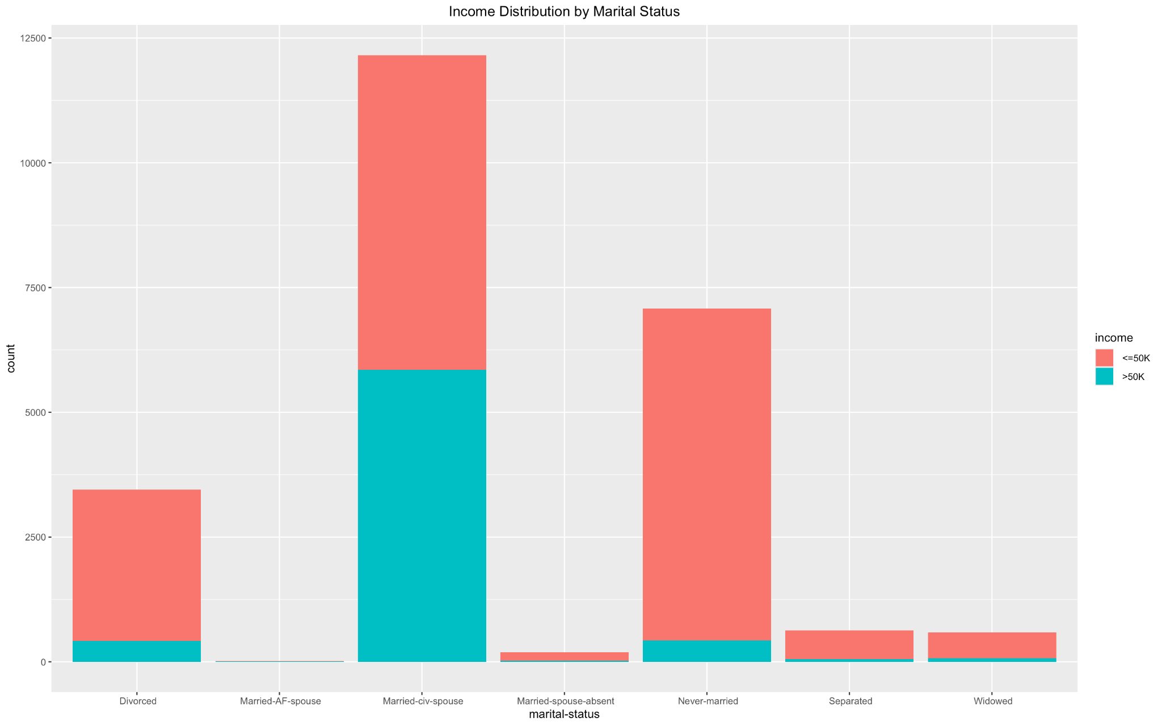

The above graph depicts the distribution of people across different marital status and the distribution of income across people that have those marital status. It may be reasonable to assign people having the marital status “Married-­civ-­spouse”, “Married­-spouse-­absent”, and “Married­-AF-­spouse”, a single class “Married”, and people having the marital status “Separated” and “Divorced” a single class, “Divorced”, for better clustering results and analysis as has been discussed before.

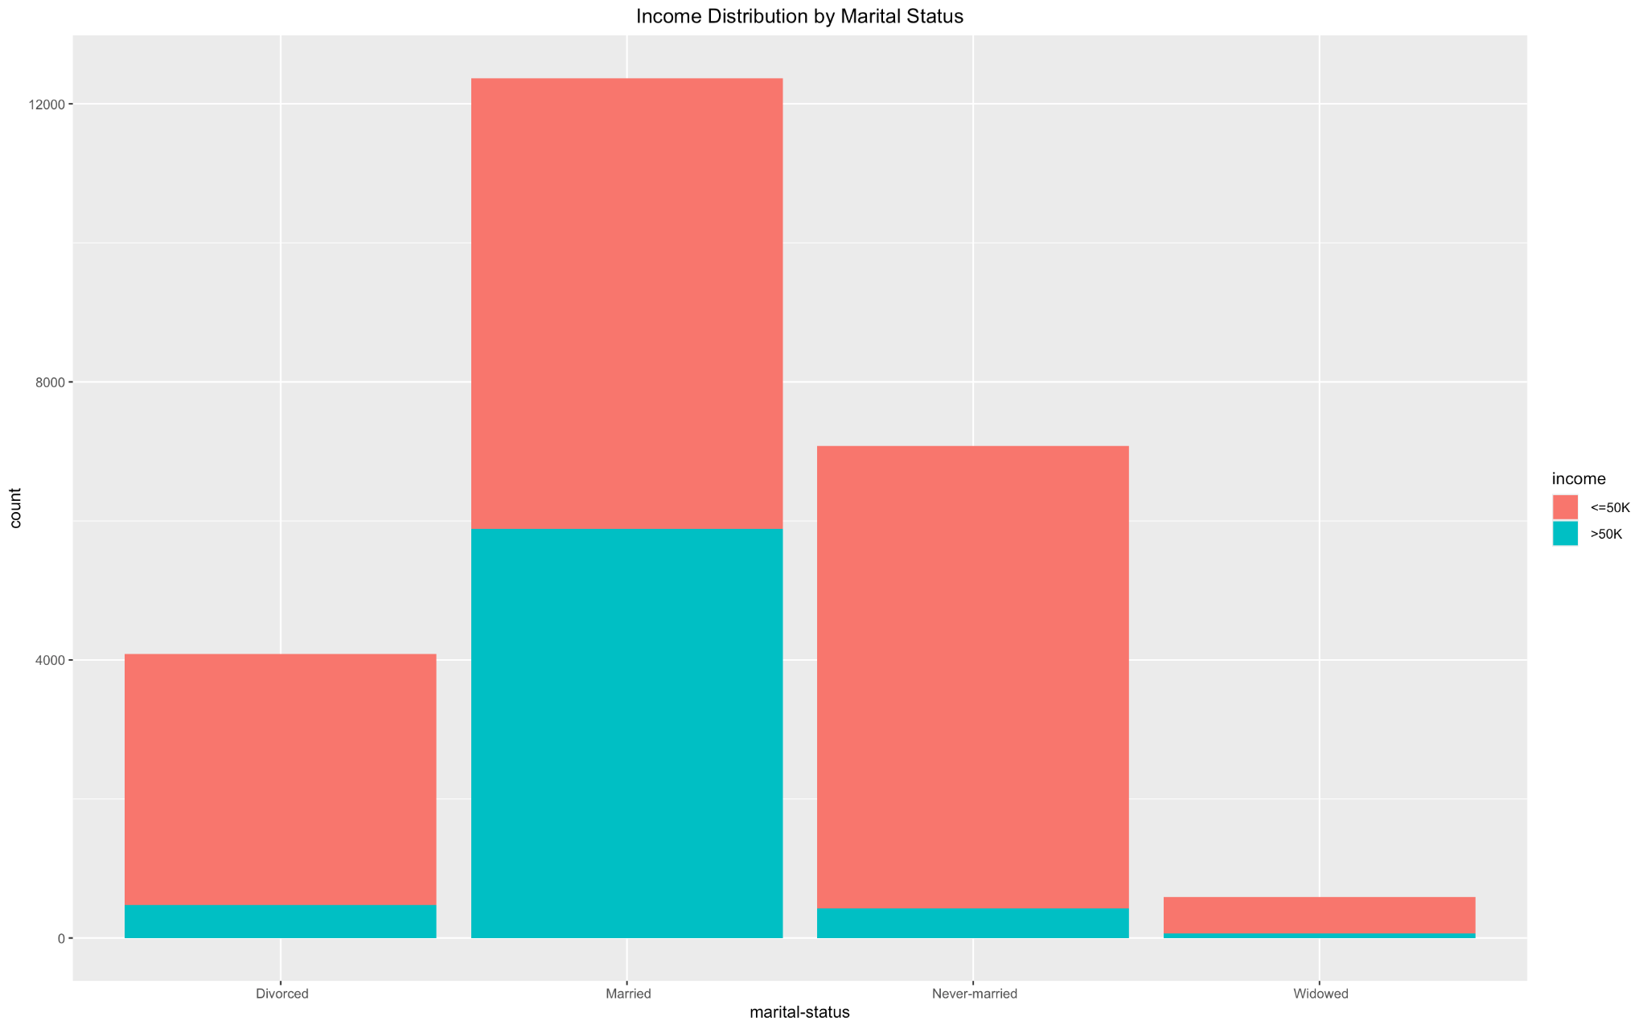

It can be inferred from the above graph that people who are married have higher incomes as compared to other classes, which is reasonable because it is associated with elevated levels of financial stability, and can have potential tax advantages and better career options. This also could be a suitable feature for clustering.

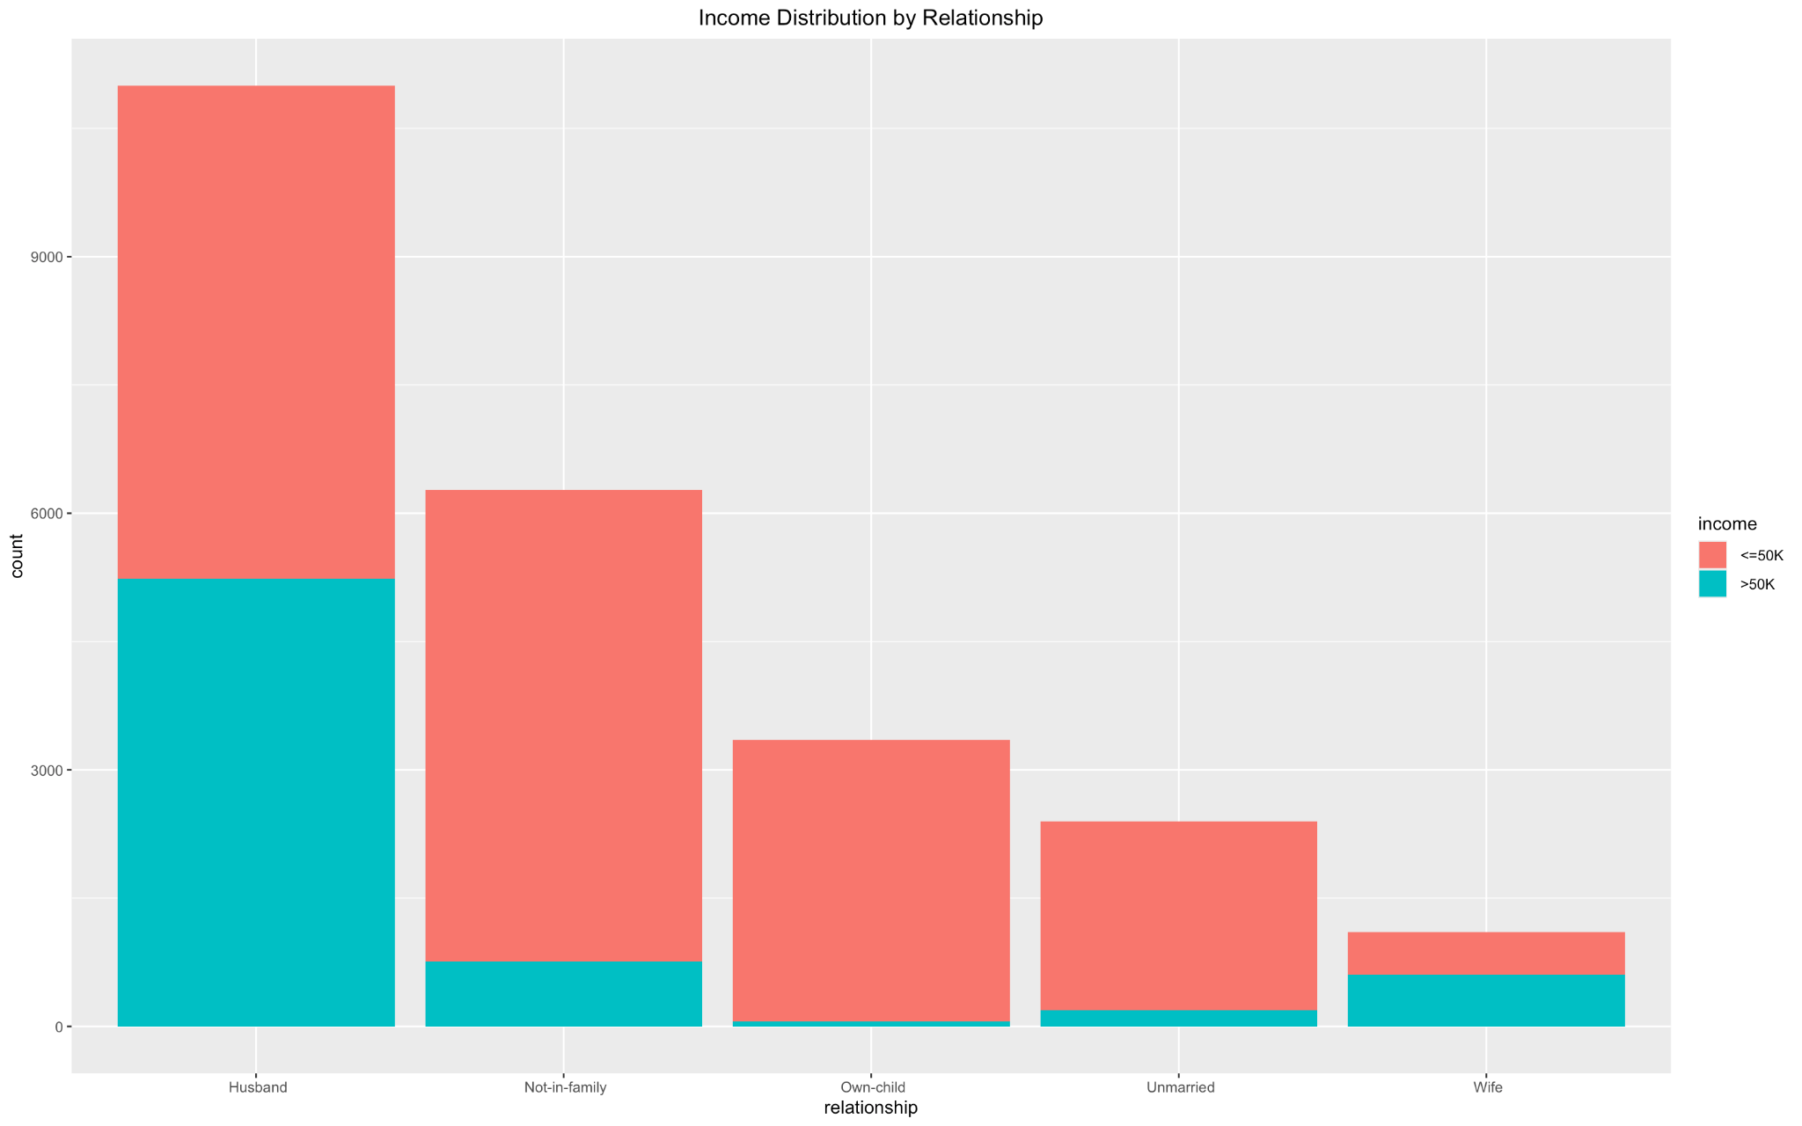

The above graph depicts the distribution of people across different relationship status and the distribution of income across people that have those relationship status. This graph again suggests that people who are married have higher income levels, however an interesting pattern is that people who have a child have significantly lower income levels. Moreover, this feature suggests that there are more males in the dataset as compared to females. By and large, this feature has significant overlaps with the features such as ‘marital-status’ and ‘sex’.

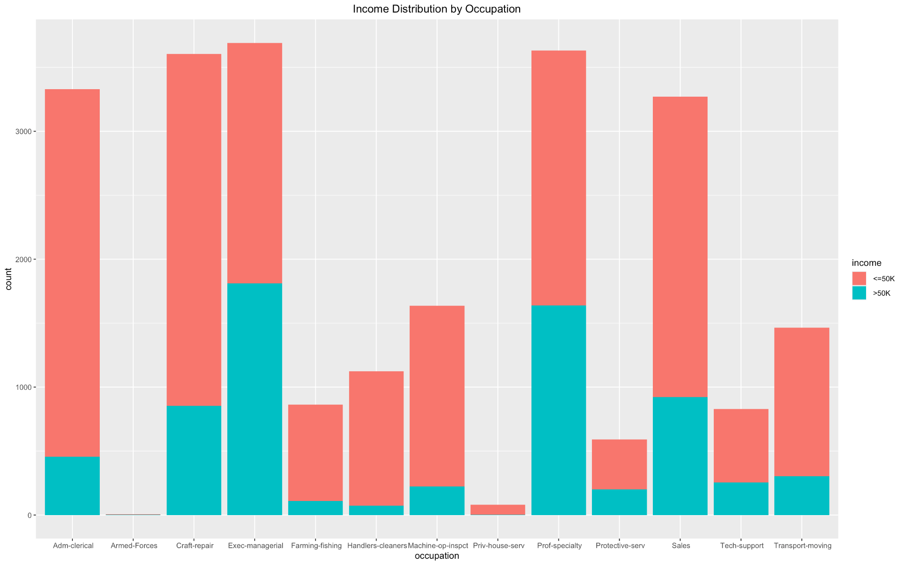

The above graph depicts the distribution of people across different occupations and the distribution of income across people that are involved in those occupations. It can be readily seen that people who are engaged in more sophisticated occupations like professors, sales, and managerial positions have higher incomes compared to people who are engaged in menial jobs like farming, cleaning, inter alia. However, an interesting trend is that more people are engaged in some jobs like crafts and repairs and they earn relatively higher than people who are involved in tech support, protective services, and machine operations and inspections. This suggests that occupation might be a good choice in the feature selection process, because certain occupations have higher income levels than others, and certain ones are more prevalent than others. However there might be other factors influencing these trends, and require more careful inspection.

Moreover, people who are involved in occupations like the armed forces and private house servants, are very few in number and could be discarded for high quality results.

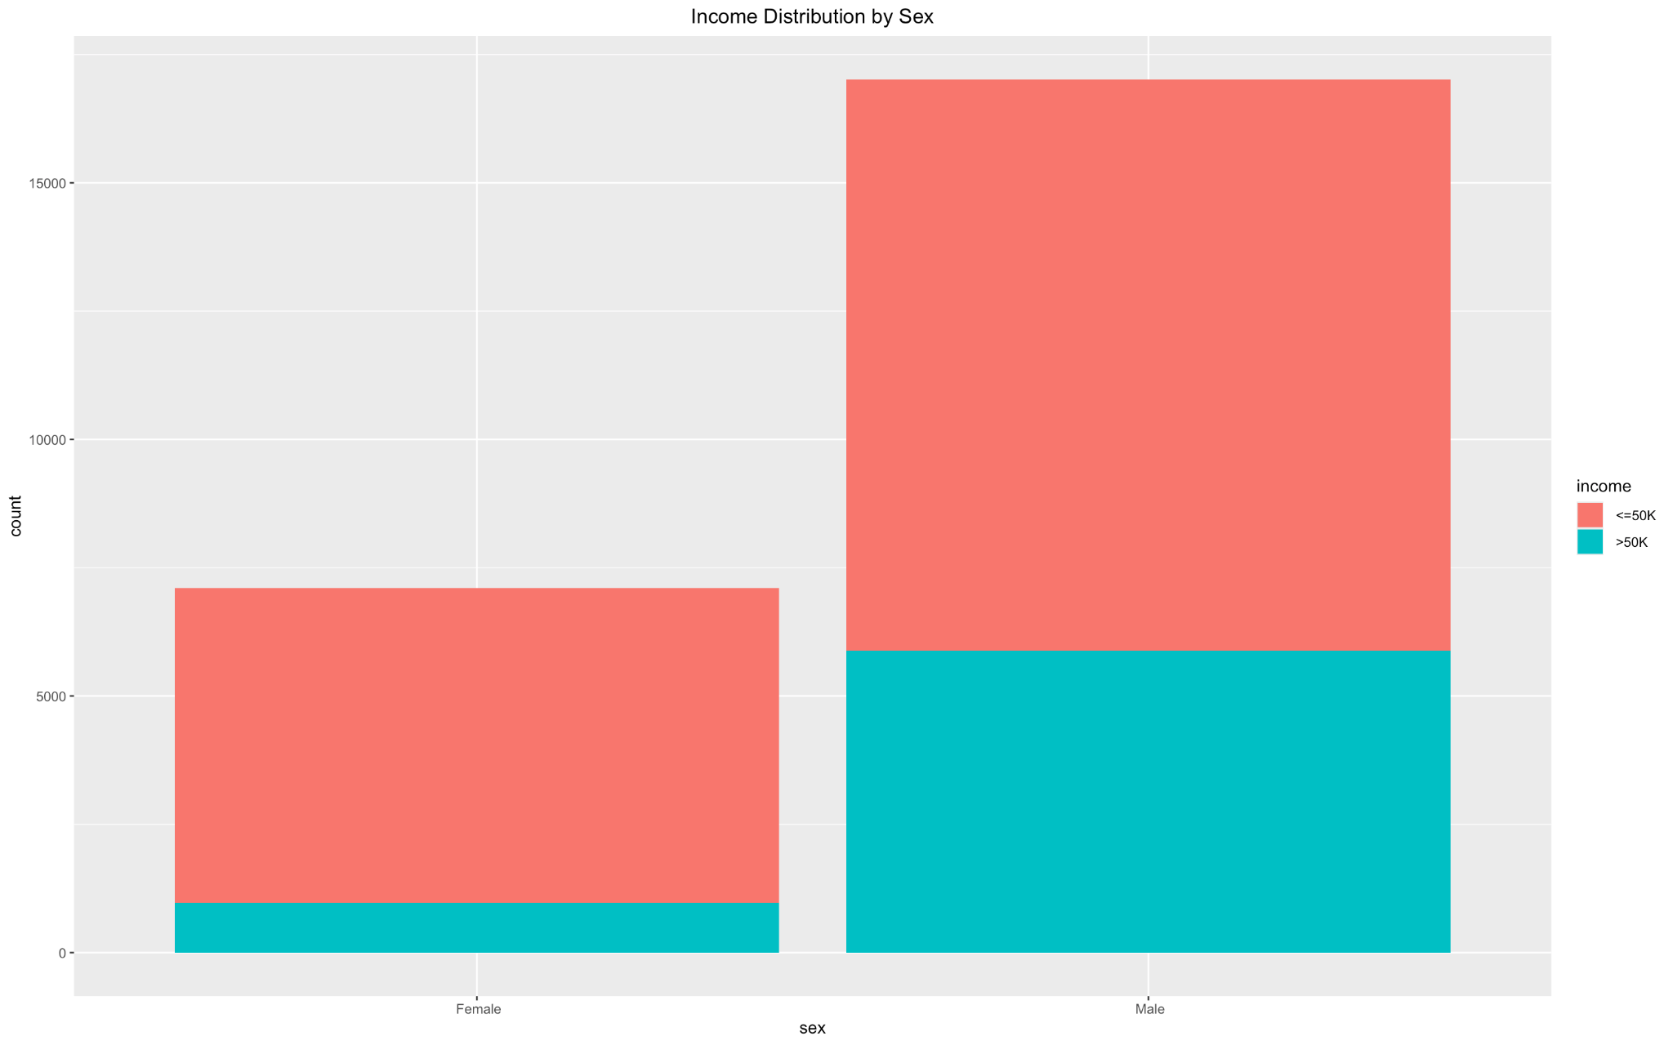

The above graph depicts the distribution of people across different genders and the distribution of income across people that have those genders. It can be seen that the dataset is biased towards males, and they also have higher incomes as compared to females, suggesting that ‘sex’ could be an important factor in clustering.

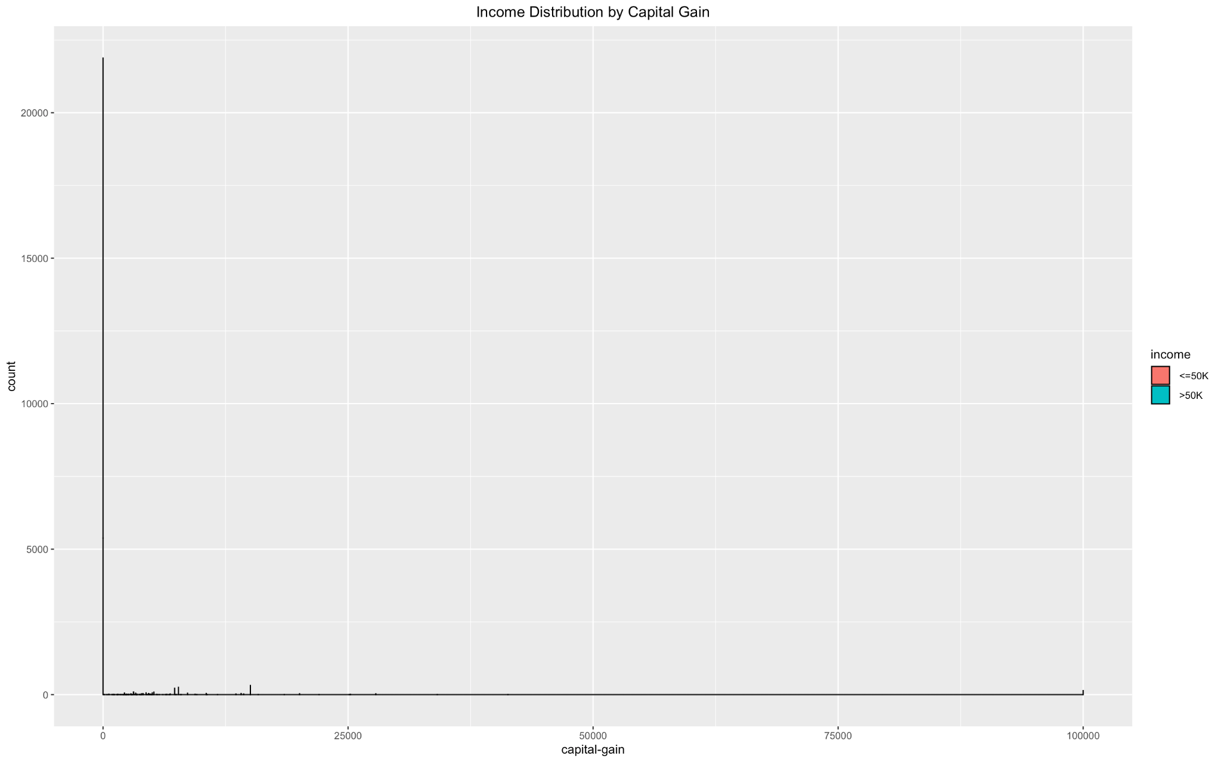

The above graph depicts the distribution of people across capital gain and the distribution of income across people that generated the corresponding gain. It can be seen that almost all of the people in the dataset do not have any capital gain and it may seem reasonable to discard this feature.

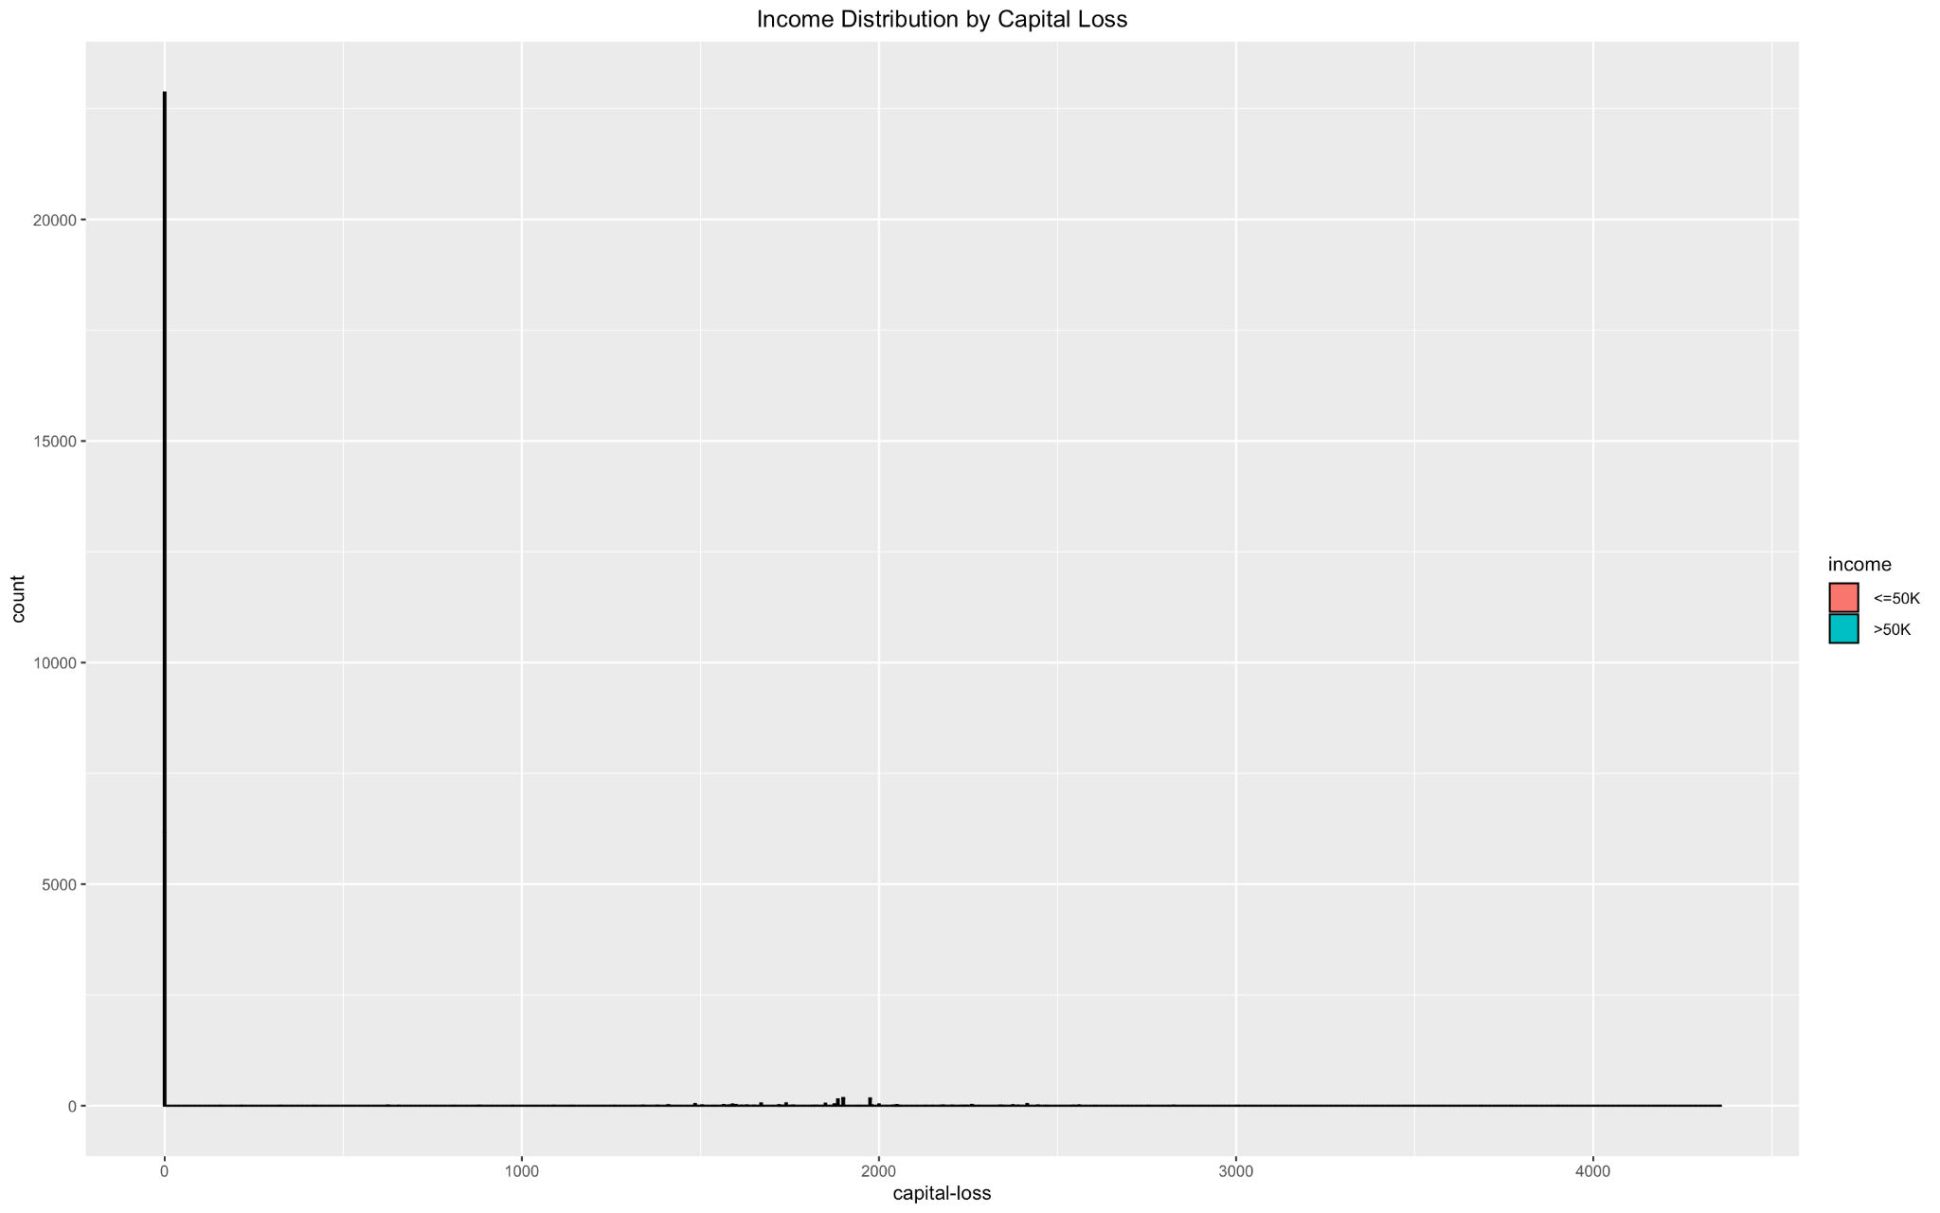

The above graph depicts the distribution of people across capital loss and the distribution of income across people that caused the corresponding loss. It can be seen that almost all of the people in the dataset do not have any capital loss and it may seem reasonable to discard this feature.

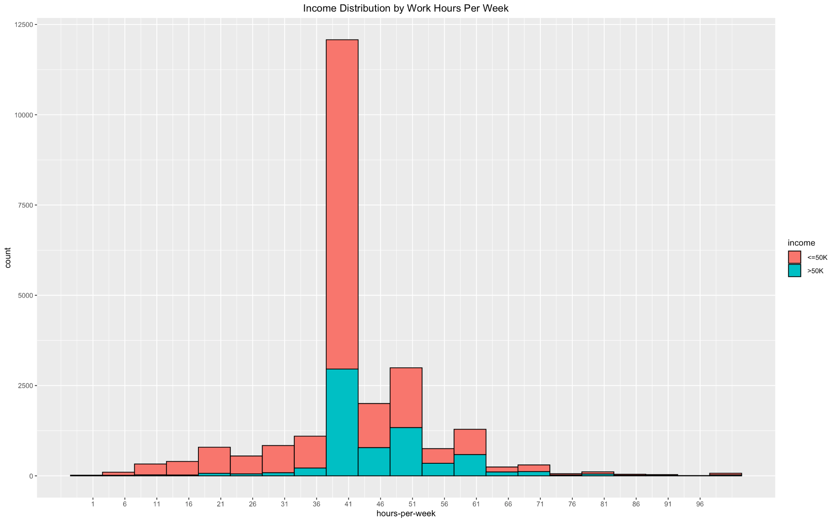

The above graph depicts the distribution of people across different working hours per week and the distribution of income across people that report to work for the said hours. It can be seen that as the number of work hours increases, the income increases and there is a sudden increase at around 38-40 hours and then it decreases. This is an interesting trend but it might depend on a lot of other factors like the occupation, which means that people who perform menial jobs for longer hours are not paid as much as people who perform more sophisticated jobs for a lesser number of hours. It might also depend on the age, skills, and education level of the person, and requires a more careful consideration. This suggests that work hours per week might be a suitable candidate for clustering.

Moreover the outliers in numerical variables like hours per week will be dealt with after performing standard scaling using the conventional threshold of 0.3%.

In a nutshell, graphical analysis and visualization is a crucial and indispensable step of data preprocessing. The above analysis provided useful insights and helped make a lot of subjective decisions like merging classes, filtering out candidate features for clustering, and dropping extremely low frequency classes.

Based on the aforementioned analyses, the following cleaning strategies were adopted,

Filtering out other countries and focusing on the United States, merging other classes within race to ‘People of Color’, discarding people working without pay in the ‘workclass’ feature, combining several classes within marital status to ‘Married’ and ‘Divorced’, discarding people working in armed forces, and private house servants from the ‘occupation’ feature, and discarding features like ‘native-country’, ‘capital-gain’, ‘capital-loss’, ‘fnlwgt’ for reasons already discussed, and ‘education’ because it is redundant with ‘education-num’.

## Data Transformation

After the initial data cleaning, the categorical variables were one hot encoded. This is because for the most part, clustering algorithms work by calculating proximity or distance between data points which can only be performed on numerical features. Moreover, one hot encoding is very useful for nominal variables that have no inherent ordering leading to more meaningful results. One hot encoding achieves this by transforming every class within a nominal variable into a binary vector thus ensuring every class is an independent dimension, in turn allowing the algorithm to compute ‘proximity’ more accurately as each class is considered equidistant from each other.

Moreover, the most frequent dummy classes were dropped after one hot encoding, to eliminate multicollinearity, which if not done could reduce the algorithm’s capability of identifying distinct clusters. Dropping dummy columns reduces redundancy, and leads to increased performance.

Additionally, dropping the most frequent dummy is preferable to dropping a dummy column randomly, because the most frequent dummy is a baseline, and dropping this allows the comparison of other classes to this baseline, which is more useful. In the proposed solution both methods were tried, but dropping the most frequent dummy gave better and more distinct clusters.

After one hot encoding, the data was regenerated by combining different types of features, and sampled. 15 percent of the data was sampled to strike a balance between computational efficiency with maintaining the representativeness of the original dataset. To ensure reproducibility, a specific seed value was set for the random sampling process.

Following this, the data was scaled using the standard scaling technique which involves converting the distribution into a standard normal distribution with a mean of 0 and a standard deviation of 1. Numerous scaling strategies were explored, such as min-max scaler, robust scaler, but it is believed that standard scaling is most suited for the dataset. This is because standard scaling ensures consistency, and maintains the original distribution of data, which helps in identifying and dealing with outliers of numerical features. Moreover, the standard scaler assumes that the distribution follows a standard normal distribution which is reasonable. Also this is indispensable to Principal Component Analysis (PCA), because PCA is sensitive to scale, and standard scaling converts all features to the same scale.

The constant columns or columns with zero variance were also removed from the sampled data, which remove any noise from the data and ensure consistent results.

Subsequently, Random Forests were used to aid in feature selection, along with the graphical analysis performed earlier. Random Forests utilizes decision trees and bagging, where the dataset is sampled, and each sample contains a variable number of columns and rows, and is used to fit the decision tree. This is known as bootstrapping. It measures the total reduction in Gini Impurity of the dataset, when a feature is used for splitting. The score from each tree is aggregated to get a final importance score.

Since Random Forests underscore features that provide the most information and lead to increased accuracy, utilizing Random Forests for feature selection helps in identifying columns that can lead to better cluster intra-cluster-cohesion and inter-cluster-separation. This also leads to more interpretable and meaningful clusters.

The features that we selected based on graphical analysis, common domain knowledge, and Random Forests are: "sex_ Female", "income_ >50K", "marital-status_ Never-married", "marital-status_ Divorced", "hours-per-week", "occupation_ Craft-repair", "occupation_ Prof-specialty", "race_ People of Color".

The next step involved detecting and removing outliers for numerical features, since the categorical ones were identified and removed in the graphical analysis phase. This was relatively easy to perform since the data was scaled and converted to normal distribution, the rows with values either less than -3 or greater than 3, were removed. Because according to statistics, 99.7 percent of the data lies in the range of 3 standard deviations from the mean and the rest are mostly outliers and noise. This is particularly important for models like k-means, and hierarchical clustering which are sensitive to noise and outliers.

Finally we used Principal Component Analysis (PCA) to transform data such that the identifiable clusters were formed. The way PCA works is that it creates principal components (which are linear combinations of the original features) that capture the most variation of data and hence identifies a new coordinate system. In this new coordinate system each principal component is ranked in the order of the amount of variation that it explains starting with the first principal component that explains most amount of variation in the data and so forth. This provides a new, and potentially a better view of the data, resulting in a better capture of the underlying latent relationships and clusters. This happens because the principal components capture the most distinguishing features of the data. Adopting this method led to a huge increase in the average silhouette widths and significantly reduced misclassification of data points to clusters.

In summary, an amalgam of data transformation techniques were adopted to transform the data in the most utilitarian form for cluster identification and analysis, which included one hot encoding, dropping most frequent dummy columns, sampling, standard scaling, Random Forests, dealing with outliers, and ultimately, Principal Component Analysis (PCA).

# Clustering Methods and Results

Following the selection of features using the random forest model coupled with our understanding of domain knowledge, we used PCA to reduce the dimensionality of the data set while retaining as much variance as possible which would be essential for clustering in terms of removing the noise and focusing on the most important features

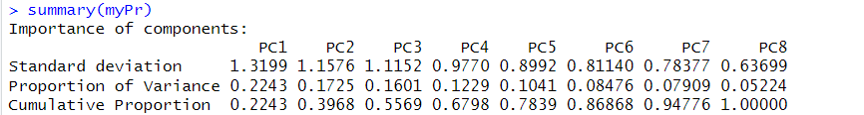

We observed that PC1 explained approximately 22.43% of the total variance, and PC2 explained 17.25% of the total variance meaning that the first 2 components are the most significant.While, PC1 to PC6 explained around 86.868% of the total variance combined.

The Scatterplot using ggplot was created with PC1 and PC2

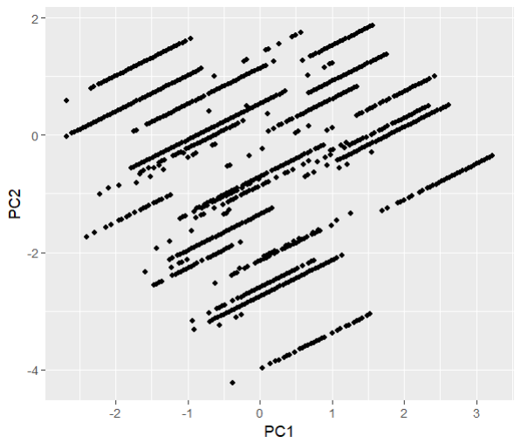

The X axis represents the first principal component whereas the Y axis represents the second principal component

The parallel lines formed in the diagram show that the decision boundaries are linear

Using linear combinations of features we could achieve separability, like in the diagram using PC1 and PC2

This indicates that the clusters would clearly capture different aspects of the data.

In order to determine the optimal number of clusters we used a range of techniques with the fviz_nbclust function, starting with K means for partitioning the data into clusters with Within-Cluster Sum Of Squares method to calculate the WSS for different values of k set at 25.



We explored a range of counts of the cluster up to 25 to find the optimal value.

We chose the value of k where the WSS starts to level off, experimenting with different values based on our own judgement

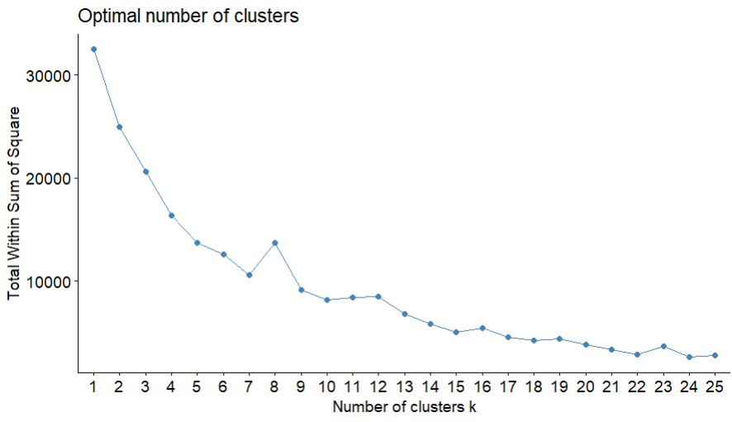

Looking into the probable values we saw the points where the WSS curve started to flatten out significantly.

The values of 7, 15 and 22 seemed to be likely points which we experimented with and analyzed.

We then moved on to using the fviz_nbclust function with the silhouette method to determine the optimal number of clusters.



The silhouette score determined how ideal the cluster separation is, the similarity of each data point was quantified and compared to the other clusters.

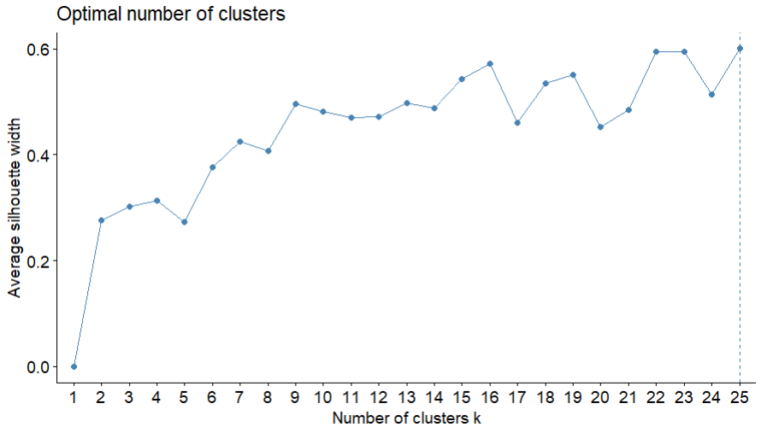

Although the method deduces the optimal k to be at 25 , there isn’t a clear distinct peak to deduce since we observe a fluctuation across different values starting with 4 then 8, 15 and 21

Using the gap statistic method, we transformed the data using PCA and applied it into the function to compute the gap statistic for different values of k

The best value of k corresponded to the largest gap between the expected and observed WSS.

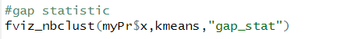

Exploring the relationship between the number of clusters and the ratio of between-cluster sum of squares to total sum of squares using the k means algorithm

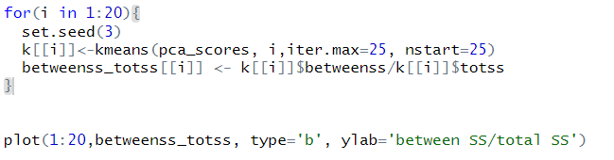

It iterated over values from i to 20 to perform K- means clustering on the transformed data to calculation the ratio for each cluster count.

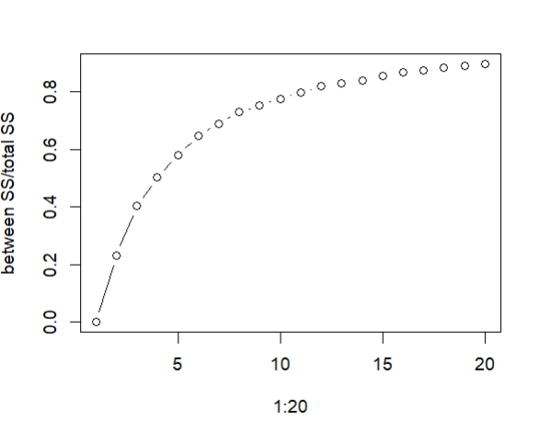

The shape indicates that there’s somewhat of a saturation effect showing reducing results as the variable increases.

It could be seen that the ideal cluster count is around 14-15 where we notice a sudden change in the trend with a slight fluctuation, however this is completely subjective and can only be confirmed based on further evaluation

We considered multiple methods to avoid solely relying on one metric since the optimal k can always vary based on the data and context, so we compared the results using different decisions to make a better decision

To identify the optimal number of clusters by looking for the gaps in distance at which the clusters are formed we plotted a dendrogram to visually see the structure of the data and make better decisions as to how many clusters we should conform to

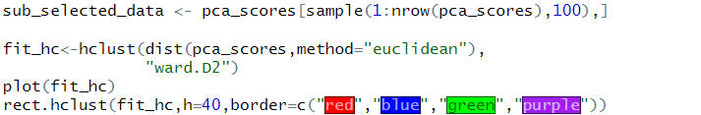

We randomly sample 100 rows to reduce computational complexity and make the dendrogram more easy to understand, by not fitting it with too many points of data

For measuring similarity between data points, we kept the Euclidean distance as it is efficient in terms of computation and pretty feasible primarily when it comes to lower dimensional spaces

Exploring other possibilities, since Manhattan distance tends to form rectangular shaped clusters, it would not be ideal in out case as it may not align with the natural shape of the data. It also often results in a huge distance value range which could impact the results of clustering negatively which is why we did not opt for it

We performed the hierarchical clustering using the Wards minimum variance method, it minimizes the total within cluster variance so that we have clusters that are more balanced and less sensitive to noise and outliers which led to more stable clusters as seen in our scenario, compared to other methods like single linkage clustering which looks at the minimum distance between points and often leads to long chain like clusters coupled with a lot of noise.

The centroid linkage clustering was also a factor worth considering, however it tends to have a static recursive approach, meaning that when a single data point is assigned to a cluster, the model does not evaluate other potential combinations meaning that it lacks a lot of adaptability which can distort the results

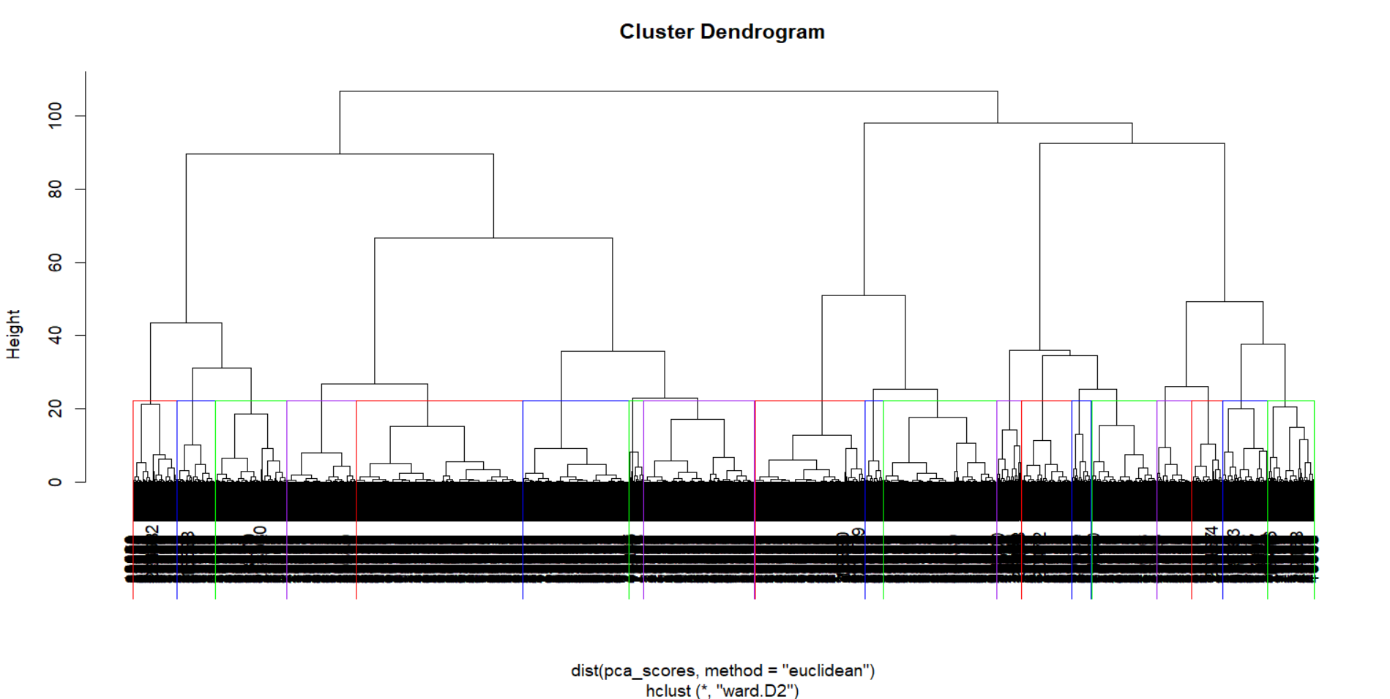

## DBSCAN

Density-based spatial clustering of applications with noise (DBSCAN) is a clustering technique that works particularly well with noisy data, when clusters are present in regions of higher densities and in arbitrary shapes. Kmeans and hierarchical clustering are both incapable of creating clusters of arbitrary shapes, and are very sensitive to noise and outliers. Another upside of using DBSCAN is that it does not require the number of clusters beforehand.

The DBSCAN clustering mainly requires two parameters minPoints and eps. eps refers to the radius of circles created around each point, and points within this radius are considered to be neighbors, whereas minPoints is the minimum number of points required within this radius for a point to be classified as a core point. If a point has the minPoints number of neighbors within the eps radius then it is a core point, if it has neighbors fewer than the minPoints then it is a border point otherwise it is considered noise and discarded when determining clusters. Then it naturally follows that the performance of DBSCAN is highly dependent on the value of eps and minPoints.

eps can be determined using a kNN-distance plot, where the distance of each point to the minPoints number of neighbors are plotted in increasing order, and the elbow in the graph gives us the optimal eps distance, because beyond this, the points are usually outliers and noisy. This follows from the fact that points in denser regions have relatively smaller distances to their neighbors and points in sparser regions have relatively greater distances to their neighbors. If it is too small then we would have too few points in the cluster and there would be a large number of ‘supposed’ outliers, and if it is too large then points belonging to different clusters would merge together. minPoints is generally supposed to be greater than the number of features, and it is a general rule of thumb to keep minPoints close to twice the number of features.

In the proposed solution, the number of features are 8, so the minPoints should be set to 8 and the corresponding kNN-value in the graph should be 7 because minPoints considers the point itself while kNN does not.

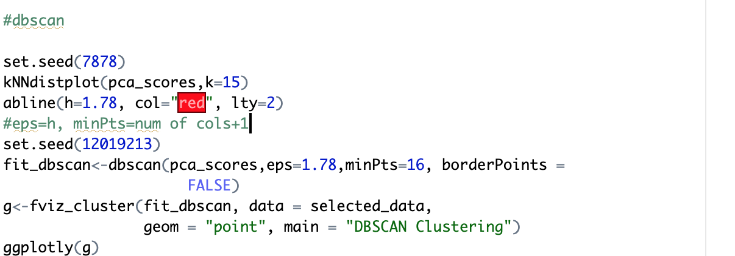

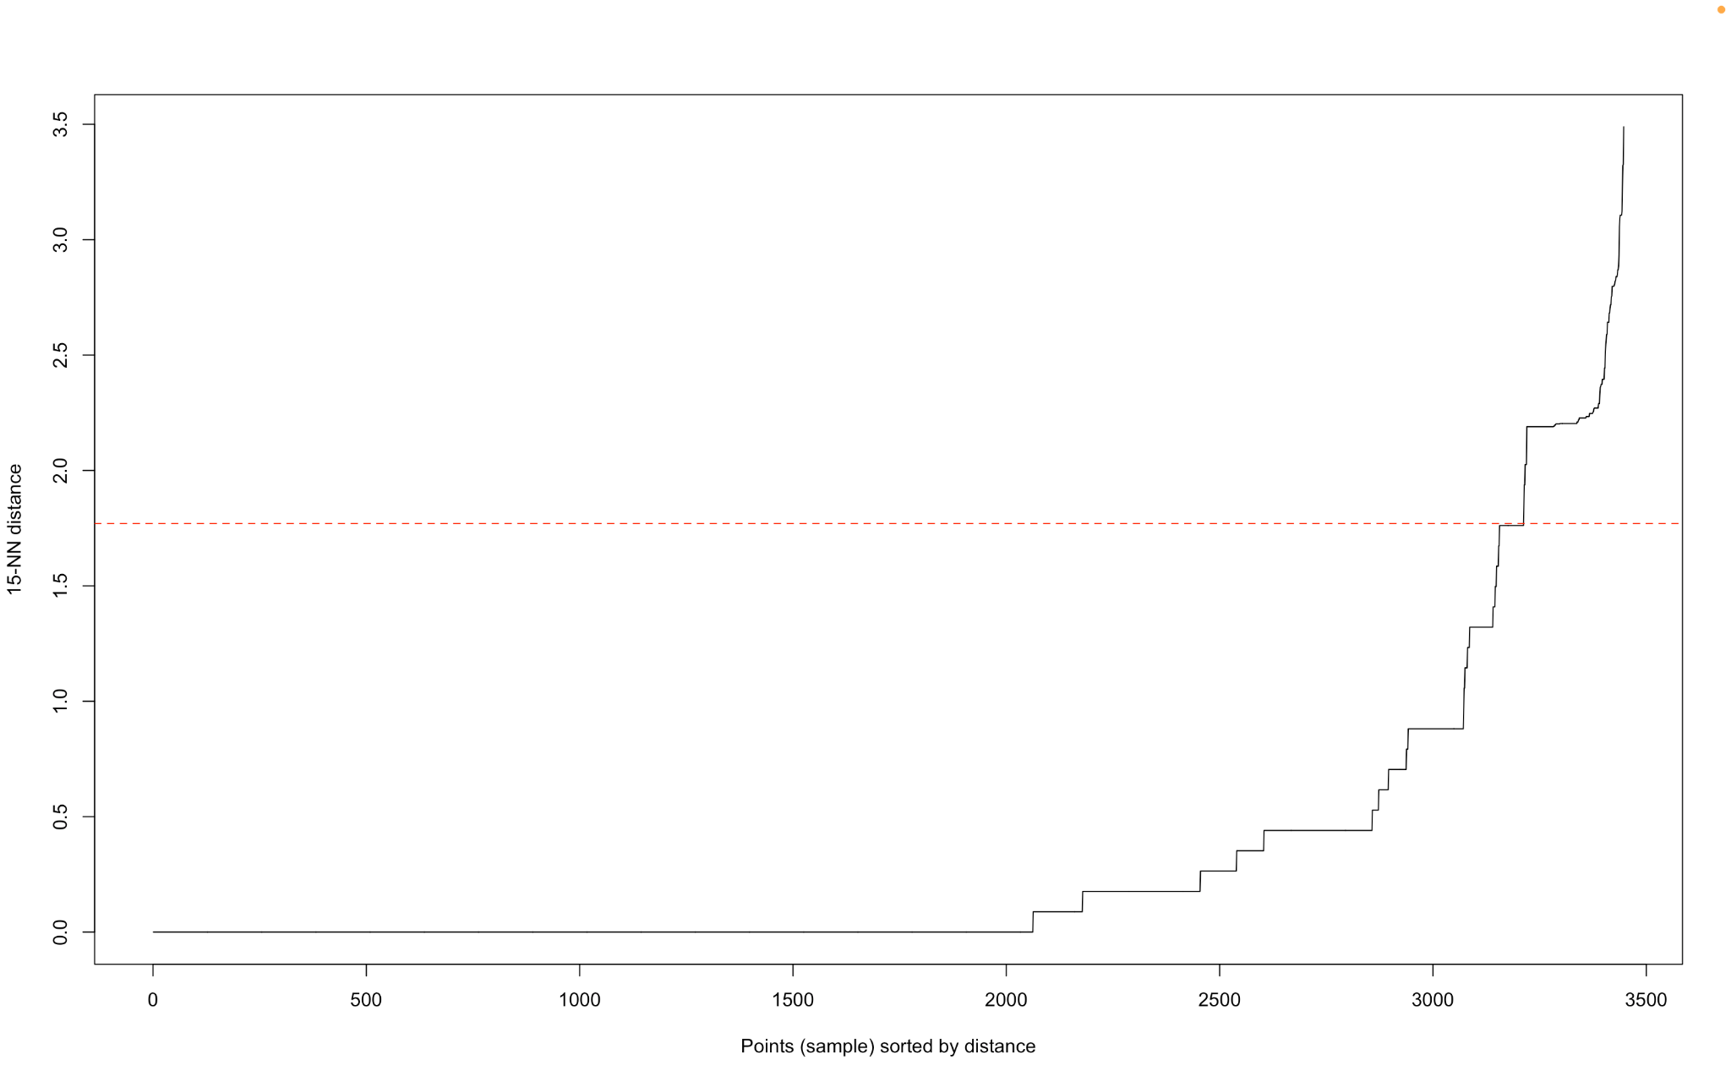

As is evident from the graph there are various elbow points like 0.88, 1.34, 1.78, and so on. The optimal distance can only be confirmed by plotting various graphs and looking at the silhouette scores, in the above case the optimal distance for eps is set to 1.78, because this gave the highest silhouette scores and other comparisons would be discussed in the following section.

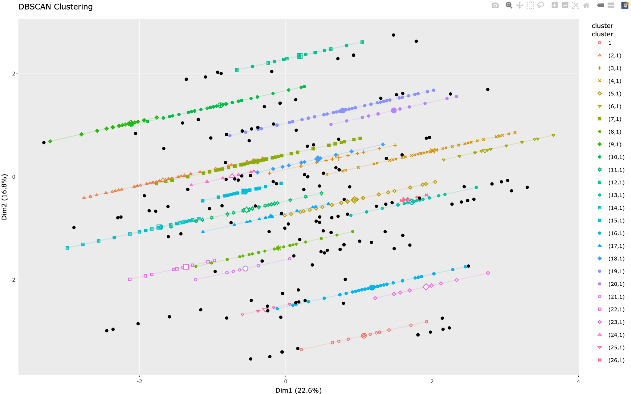

It can be seen that dbscan performs the best for the dataset under discussion, because it has some regions of high density, along with arbitrary shapes and noise which cannot be handled by other clustering techniques.

### 

# 

## 

## Fuzzy C-Means

Fuzzy c-means is a clustering algorithm that involves allowing observations to belong to multiple clusters with varying degrees of member ship. FCM assigns membership probabilities to each data point for each cluster.

Our choice for the number of clusters was base don the same methods as for k-means and similarly we test all the different k-values we identified before. We then perform the FMC cluster, deciding on the fuzziness parameter, which the higher it is the fuzzier the clustering is, based on trial and error we foudn3 to be the best:

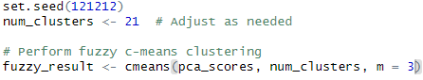

We then observe the fuzziness membership for each observation, the score represtns how much they belong to each cluster:

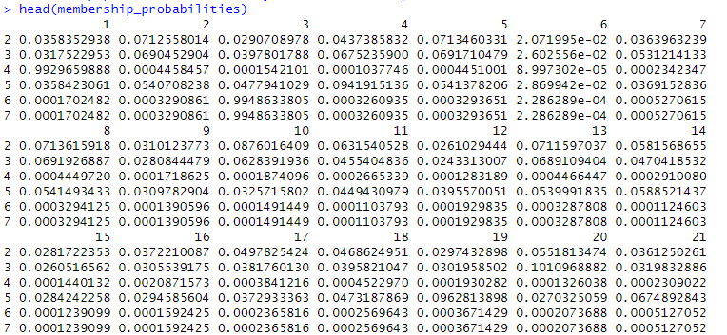

After this step we save the cluster centers in a variable and then convert them back to the original features from the principal component space using the inverse of the PCA rotation matrix and then transform into a dataframe for easier viewing and handling.



We then assign each observation to the data point in which its membership probability is the highest:





So, if u look at the membership probabilities above you can see in cluster 10 a score of 0.087 was the highest for observation 2 and so on.

We can also vizualize the clusters and their centers to get a better understanding of whether it clusters well or not:

The large star-shaped points shows the cluster centers in the plot, these centers appear well-distributed across the plot. The colored dots represent the data points, with different colors corresponding to different clusters. There is a visible spread of data points around each cluster center and each cluster can be visually identified. 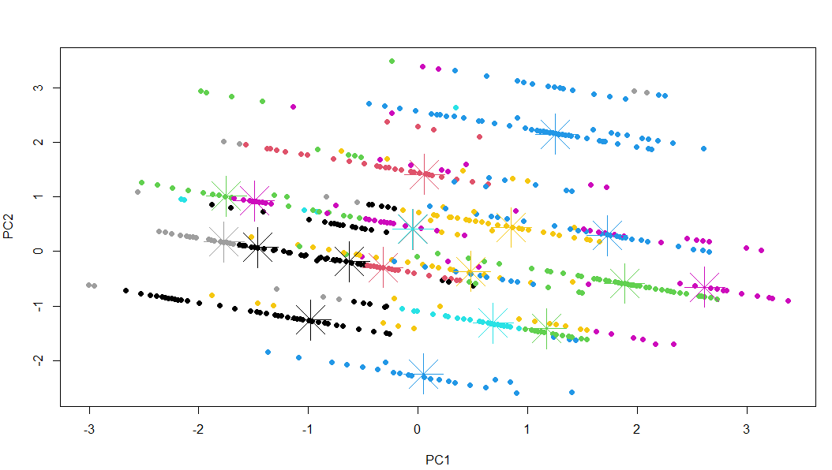

Certain clusters (e.g. those represented by black, cyan, and yellow colors) have a higher density of points around their centers, suggesting that these clusters are more compact. Other clusters (e.g. those represented by pink, green and black) have points spread more widely, indicating a larger variance within these clusters.

There is some overlap between clusters, as seen by the proximity of some clusters' data points to neighboring cluster centers. This suggests that the boundaries between certain clusters are not very distinct.

# 

# Cluster Qualities

## Intra-Cluster Comparison

The proposed solution utilizes **silhouette score method** and **davies bouldin Index** to help evaluate all the models we previously constructed.

The Davies-Bouldin index (DBI) is a metric where the cluster valuation is higher when the DBI score approaches zero. However, Davies Bouldin Index, is based on the Euclidean distance, with the assumption that clusters would be spherical and may not work particularly well in case of arbitrary cluster shapes.

Average silhouette method measures how well-defined a particular cluster is, and how well-separated it is from other clusters. The Silhouette value is calculated for each observation in the data set. Average of the silhouette value of all observations gives us the average silhouette value, which is the silhouette value of the clustering analysis. The higher it is, the better the score of the cluster is. Silhouette width plots have also been analyzed to identify and misclassification of points to incorrect clusters, which further aids in the understanding of cluster accuracy.

### K-Means

#### K=19

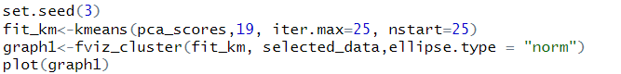

The optimal number of clusters was chosen to be 19 after considering all of the methods like the elbow method, silhouette score and gap statistics.

We selected the maximum number of iterations and n start to be 25, this is because we want to have sufficient iterations enough to converge and multiple starts would allow us to find a more efficient solution by running the algorithm with different initial centroids.

### 

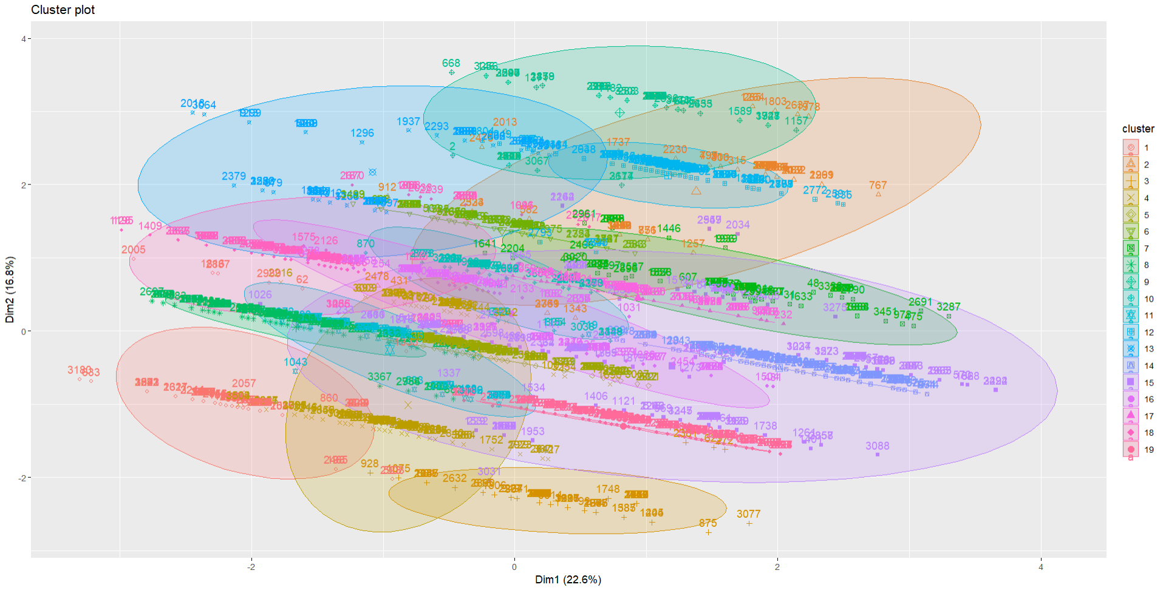

We can see that some of the clusters are well separated showing clear differences between the groups while other clusters tend to overlap for a slight portion, this is likely due to the high density within that particular region

The different shapes are expected as K means always focuses on reducing within-cluster variance, so we see a range of shapes and spreads within the clusters

**Visualizing the cluster after fitting the k means clustering algorithm**

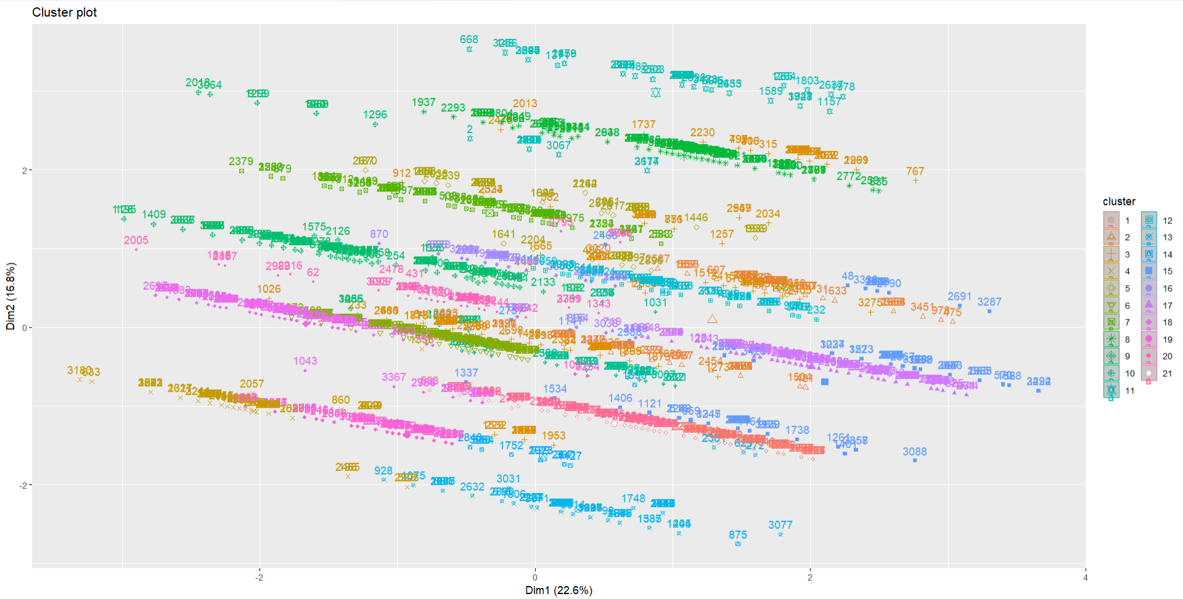

The clusters are projected onto 2 principal components, we can see that the clusters now are much more well-separated compared to having k means set at 19.

Although we have a small bit of overlap, which is slightly visible

The variation over here for different clusters might indicate the presence of sub clusters which needs to be investigated

Clusters were there are more symbols which are dense tend to show a much high concentration like clusters 7,8 and 19 while the clusters which are much more sparse like clusters 1 and 4 tend to have much fewer data points

Using the Davies Bouldin index



A Davies-Bouldin index of 1.028878 is obtained showing that the clustering here is generally reasonable but there might be a lack of separation between some clusters as seen above in the visualization of the clusters

For evaluating the cluster quality to gain insights we used a range of techniques starting with the sum of square method to see how well the data points within each cluster as grouped together

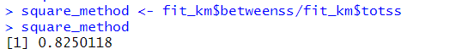

We got a ratio of 0.825 showing that the clusters are better separated and that the data points within each cluster are group together well.

We then used the Silhouette analysis technique to assess the separation distance between the resulting clusters

#### K=21

**Re-evaluation using an alternative number of clusters**

Setting k to 21 based off the silhouette is worth considering the experimentation based off the silhouette plot



Although the misclassification for certain points may be slightly higher the overall distribution of the data needs to be considered

It may be beneficial to validate this using the Davies Bouldin index to see how exactly the data points separate



We can see that there is reasonably good clustering however there can be small changes for improvements to address the large overlap in some of the clusters

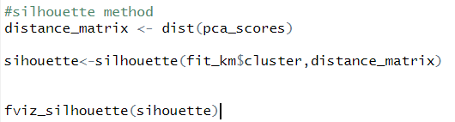

The distance matrix is calculated using the Euclidean distance between the data points in the PCA space and the silhouette scores are calculated for each data point

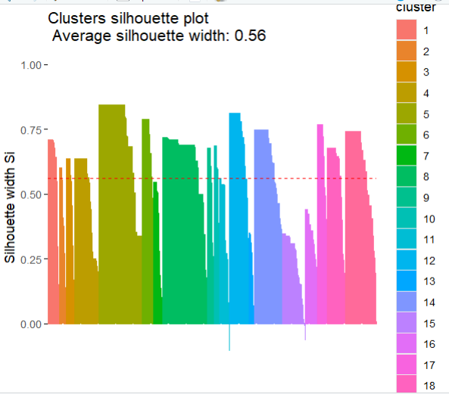

Dealing with the plot, it shows an average silhouette width of 0.56 which actually suggests a moderate level of cluster separation and cohesion, since we know that generally speaking above 0.5 indicates a reasonable level of clustering

Looking at some of the variations in the silhouette width,

Some clusters show a very high degree of consistency with most bars being close to the average silhouette width line like for example when we consider clusters 4, 7 and 12

While a few others tend to have some low values, although this is minimal, there are points not assigned ideally to certain clusters as seen.

Comparing the Davies Bouldin index with the previous value for 19 clusters we got 1.1445, indicating that k=21 has potentially better results for the index as the clusters are much more visible and almost clearly distinguishable with only a few overlaps between some of the dense clusters

Using the sum of square method

We got a ratio of 0.833 which is slightly higher than the previous 0.825 showing that the clusters are slightly better separated and that the data points within each cluster are group a bit better



Then using the Silhouette score technique we obtained the following results

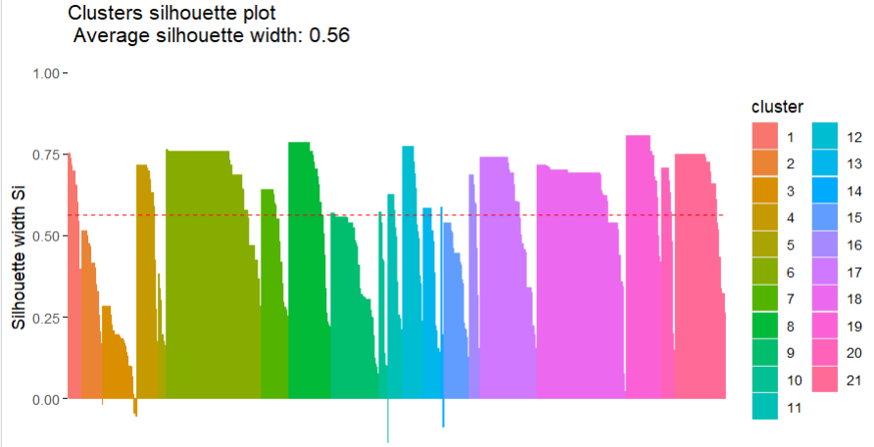

Although within each cluster , the data points seem to be distinct in contrast to k being set at 19 we see that the plot produces a slightly higher range of misclassification which might have impacted its efficiency.

The visible blue bar in the middle which extends below the line indicates some potential misclassification within the cluster

Clusters where there are many positive silhouette widths close to zero could indicate that the points are much near the boundaries and belong to the neighbouring clusters

Interestingly we see the exact same silhouette width showing that the overall distribution of the data is generally the same.

### PAM (Partitioning Around Medoids)

#### K=19

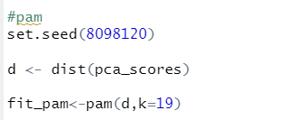

Alternatively, we experimented with another clustering algorithm PAM, a medoid-based clustering algorithm. Since it is more robust to noise and computes the distance based on dissimilarity, we used it to see how flexible its results would vary with various cluster shapes

The same number of clusters (19) was used to experiment with.

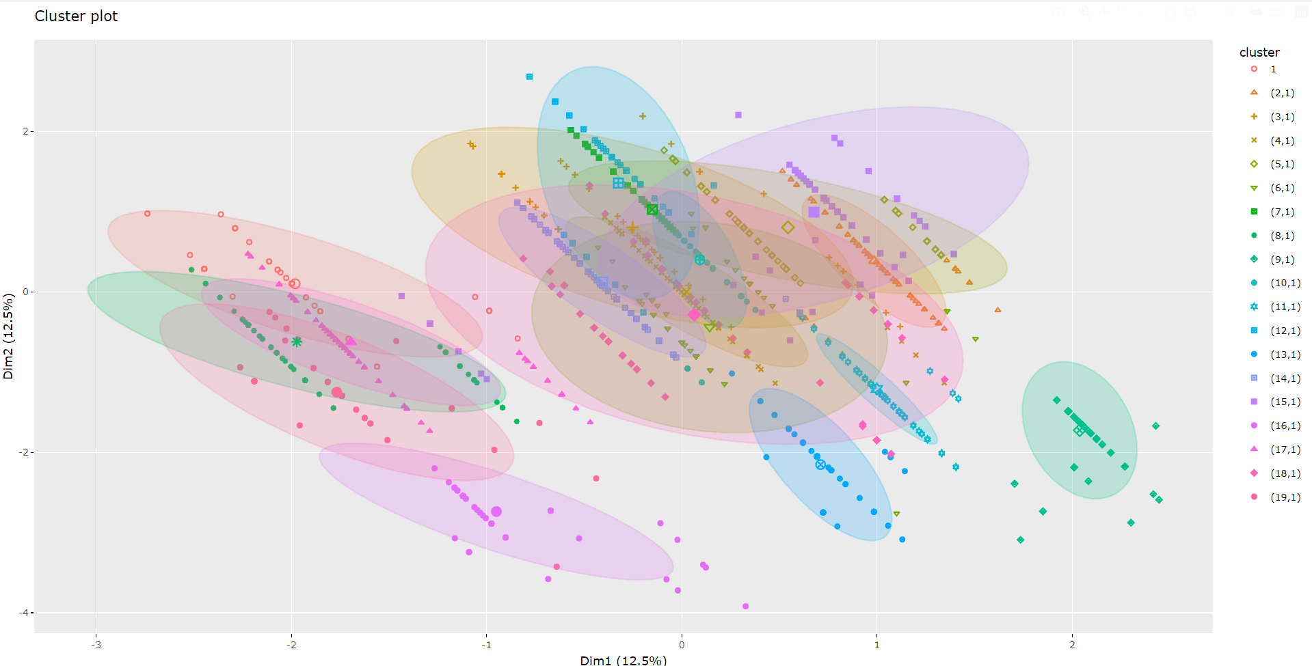

We can see that this method actually provided a much better separation of the clusters, the distinction is much more visible compared to fit_km

Some clusters are well separated indicating distinct groups like clusters 13 and 14

Based on the orientation of the cluster, we can see that there is much more variability in the points when there are larger ellipses

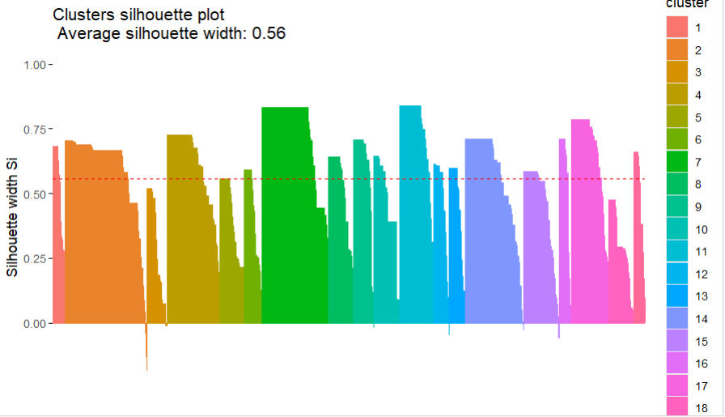

The average silhouette width of 0.56 shows that the overall cluster is seemingly good, it is the exact same value obtained from the fit_kmeans method.

Clusters like 6,8 and 10 have higher average silhouette width showing stronger well defined clusters

While clusters like 1 and 2 have much lower width showing poorer performance for the groups

Clusters 7,11 and 14 show a wide range of widths showing that some points are well clustered while others could be classified as outliers or misclassified

Clusters with silhouette values are more compact and well separated from other clusters

Given the average silhouette width, we can experiment with other k values to see how other values work relative to different values

#### K=21

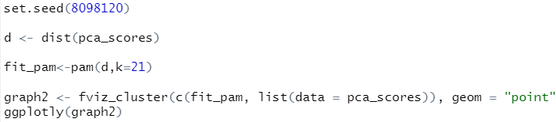

Setting k=21 we experimented with PAM to see how the distribution of changes alter with respect to the change in clusters

Visualizing the clusters, we obtained the following diagram

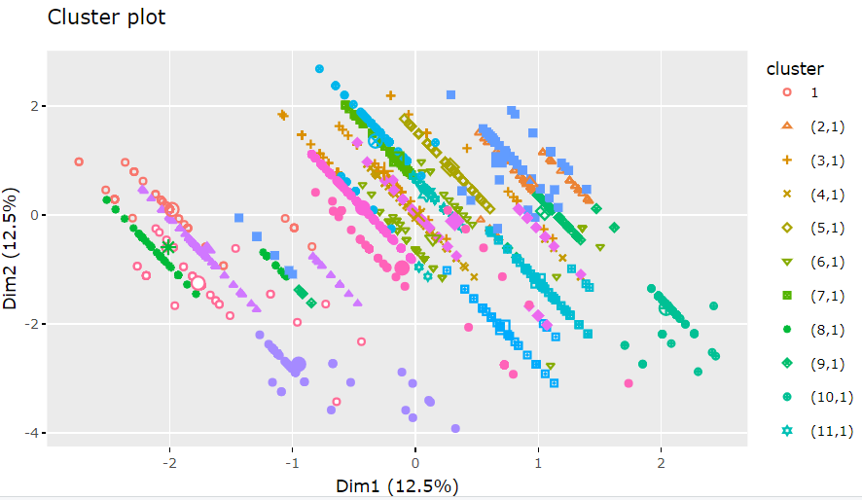

In contrast to the previous value of k set to 19, we notice that the clusters are much better defined in this case with only a few values of noise.

Although there is a slight distortion of data points skewed around in random areas which indicate that the data points could have been fitted much better

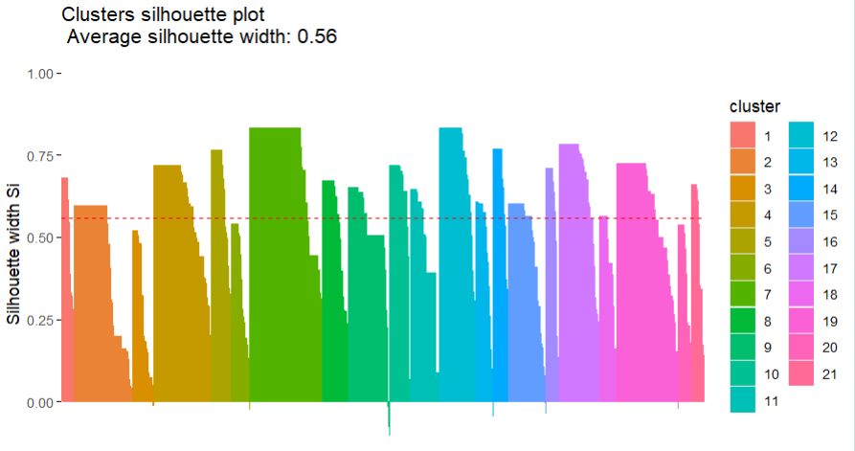

The Average silhouette width with k set to 21 showed much better results with a value of 0.56.

Even though there is a slight bit of misclassification as seen in the diagram, the dense regions are much broader and well fitted as compared to k=19 which is expected whenever we increase the value of k.

### DBSCAN

#### Eps = 1.78

Davies-Bouldin index for Db-Scan clustering: 0.6382969

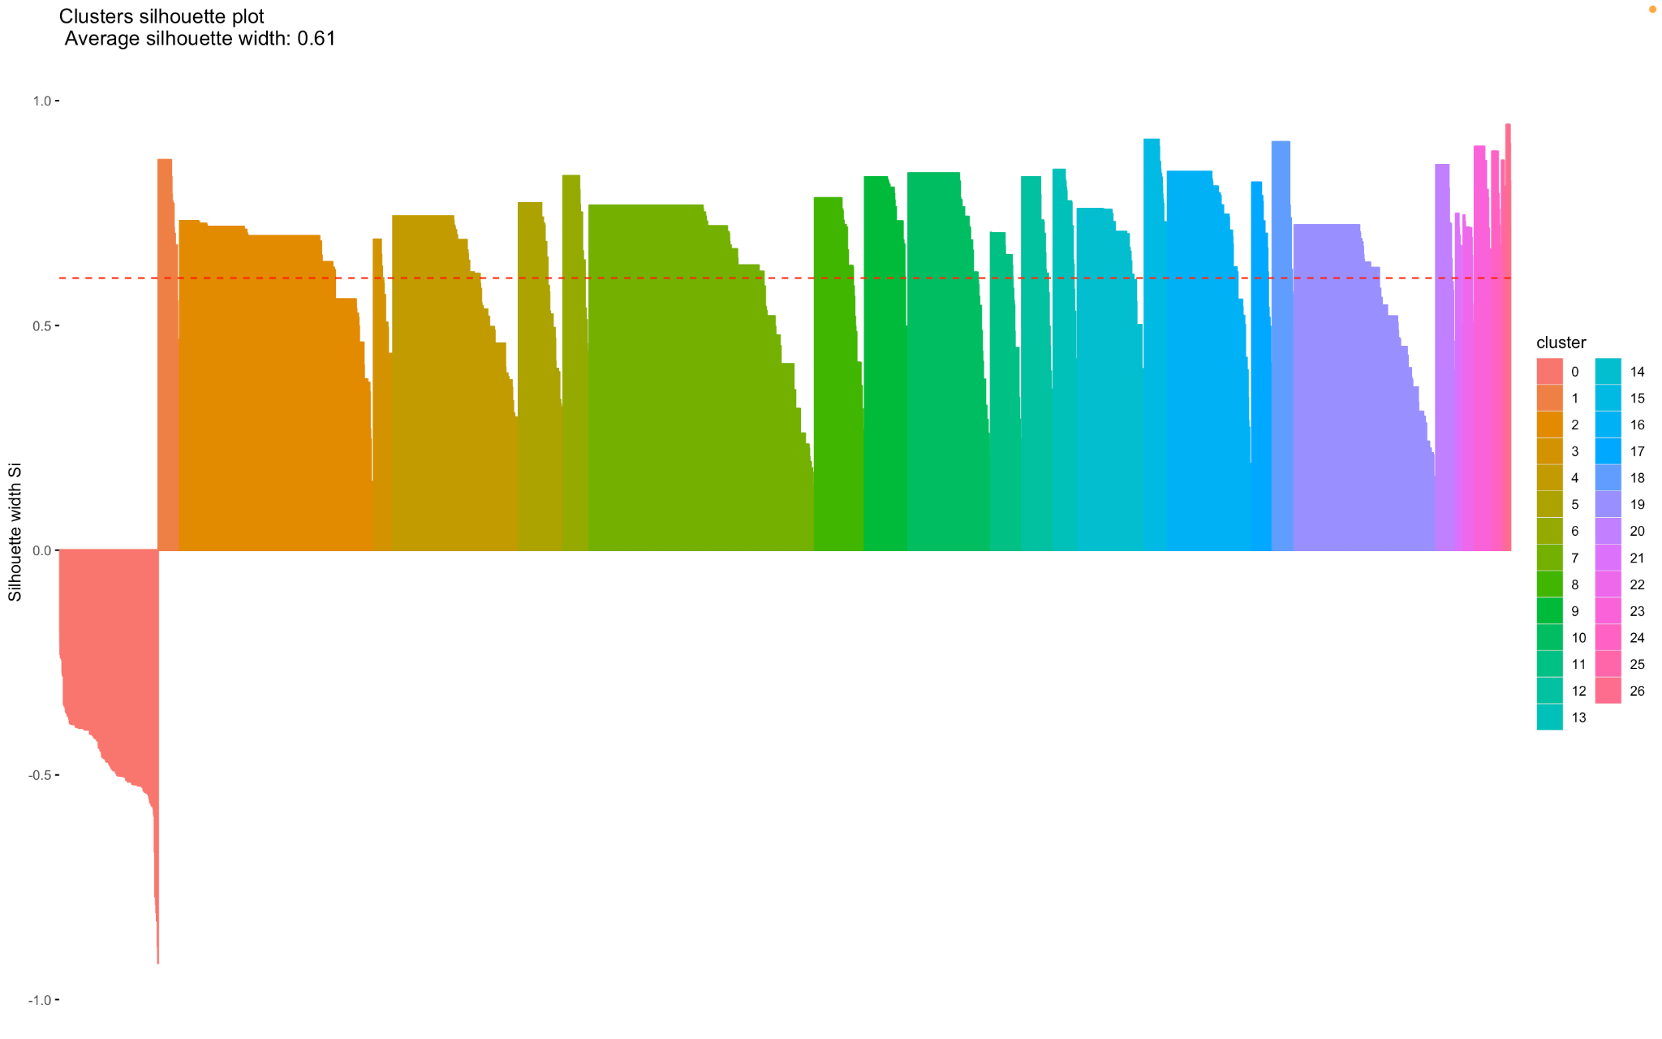

It can be seen that the DBSCAN method works particularly well with this dataset. In the silhouette plot it can be seen that none of the points have been misclassified, almost all the silhouettes have near equal height, implying a good and stable solution. It is to be noted, that the average silhouette width is much higher than indicated, because it also takes into account the silhouette width of noise which is not very useful for us, so the silhouette width calculated without the noise points turns out to be close to 0.69 which indicates that the points of the clusters have been very well classified and there is good balance of cohesion and separation.

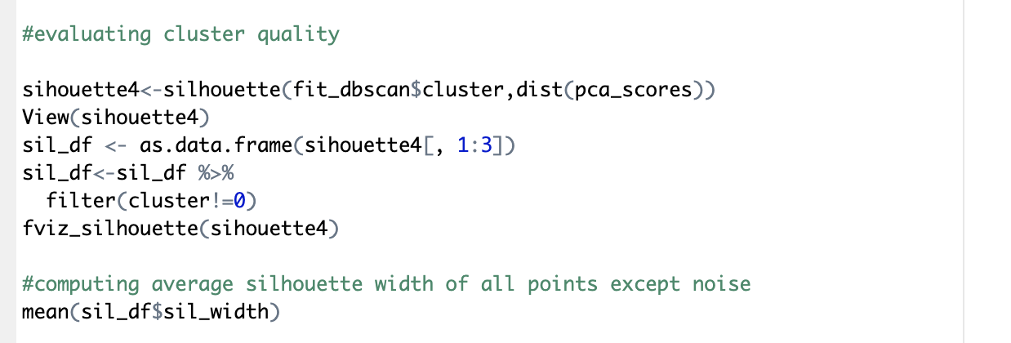



#### Eps = 1.34

Davies-Bouldin index for Db-Scan clustering: 0.5551503

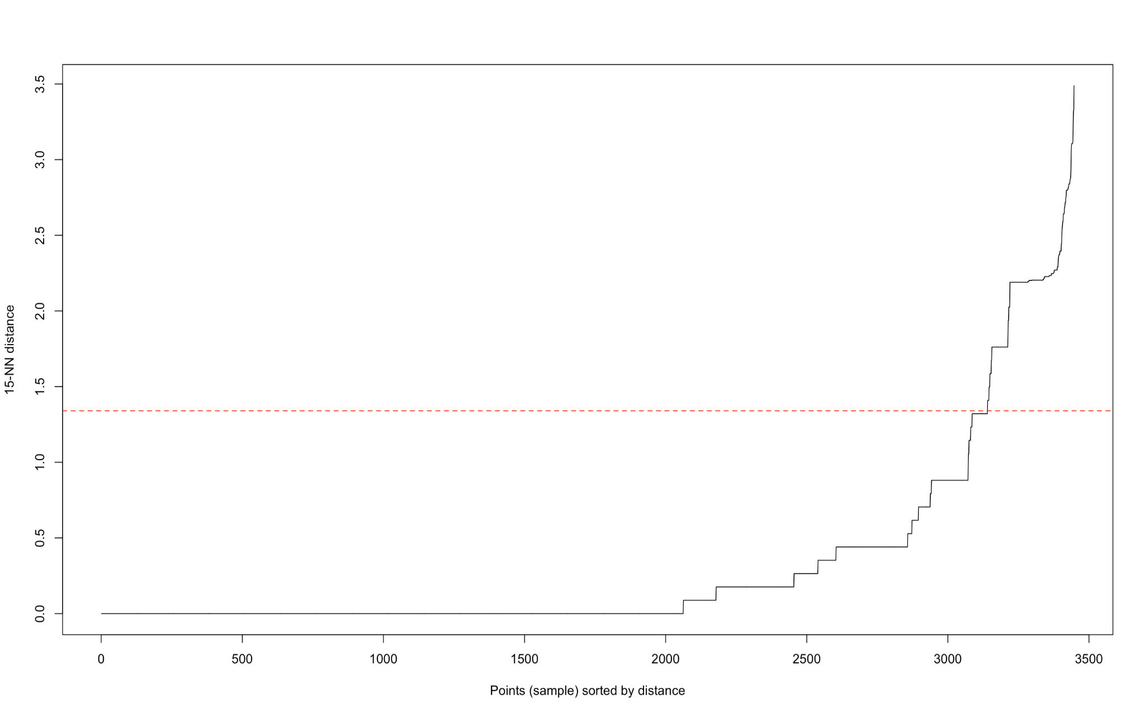

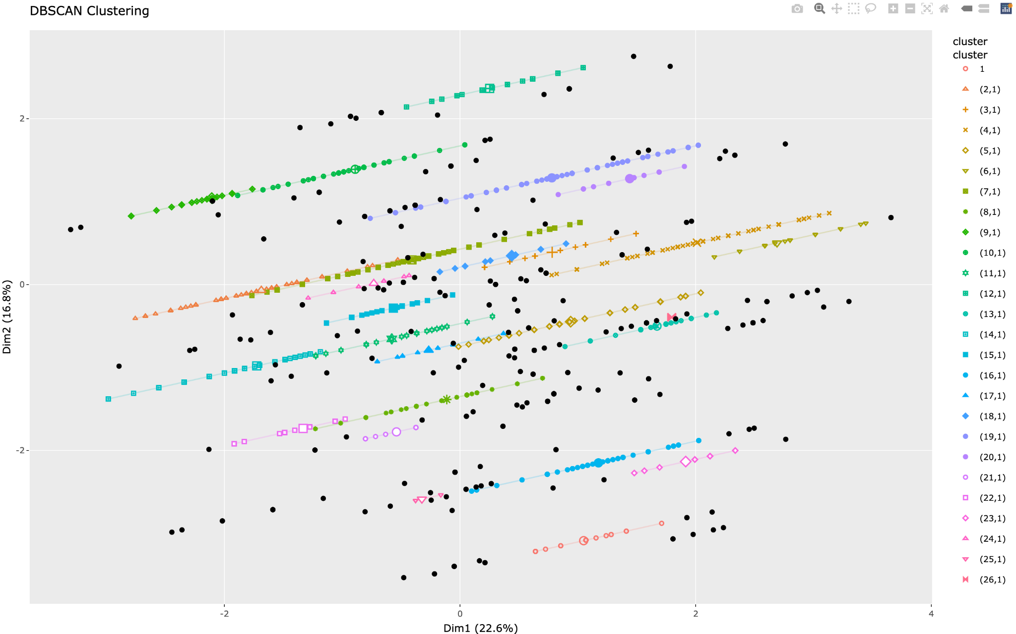

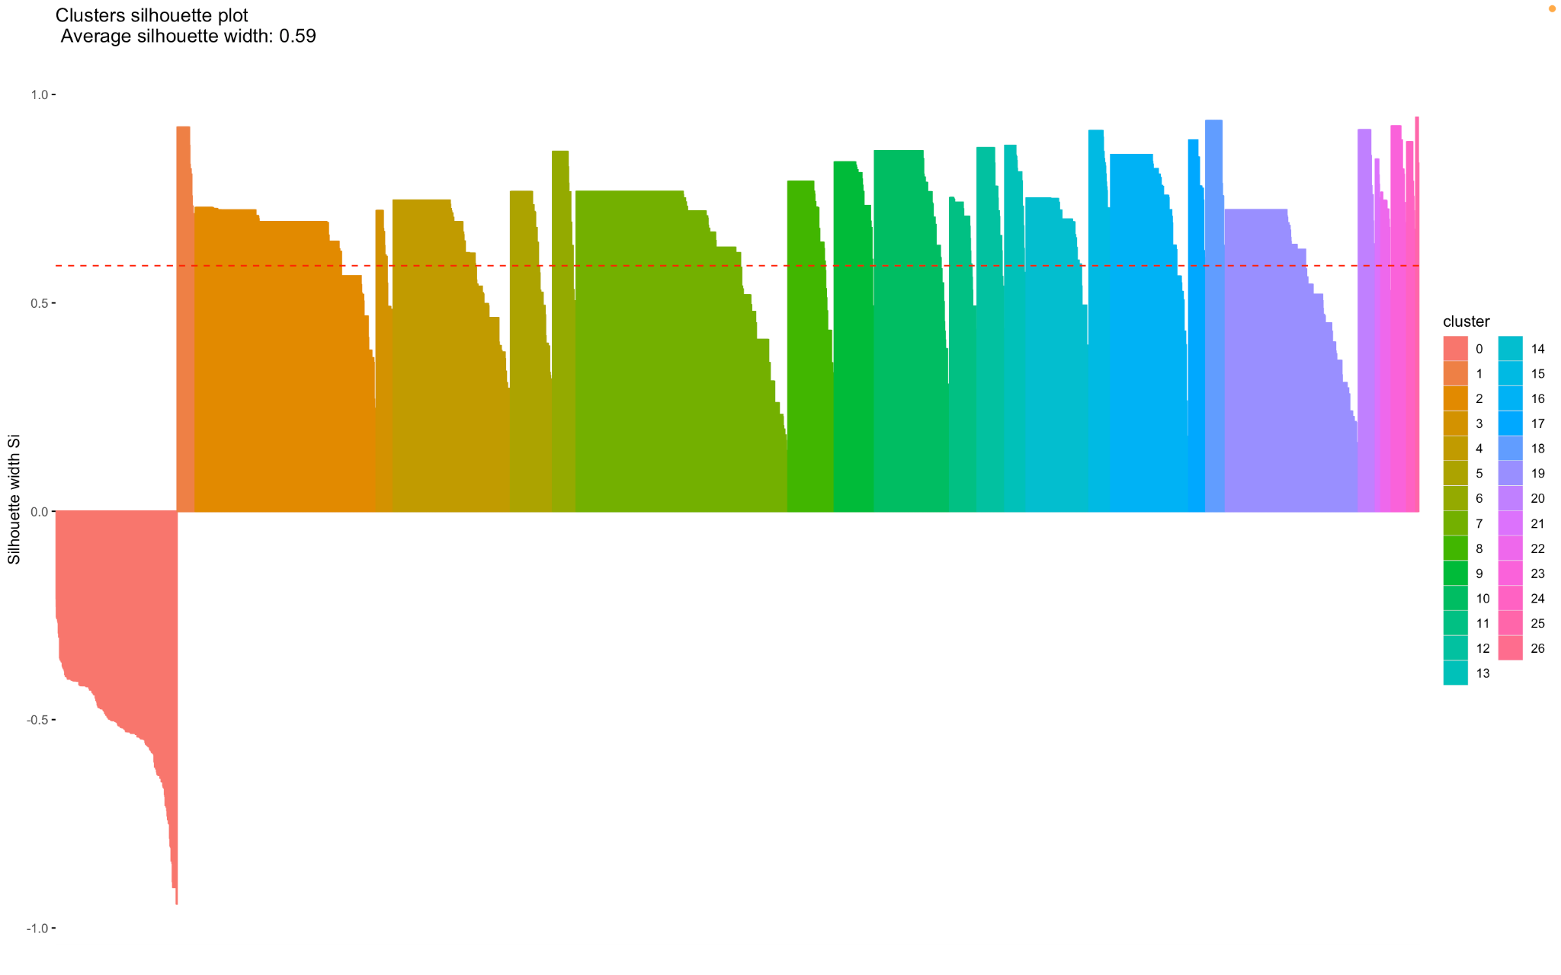

It can be seen that the number of clusters has increased and the quality decreased. It also identifies some noise points as parts of the cluster.

#### Eps = 0.88

Davies-Bouldin index for Db-Scan clustering: 0.4641702

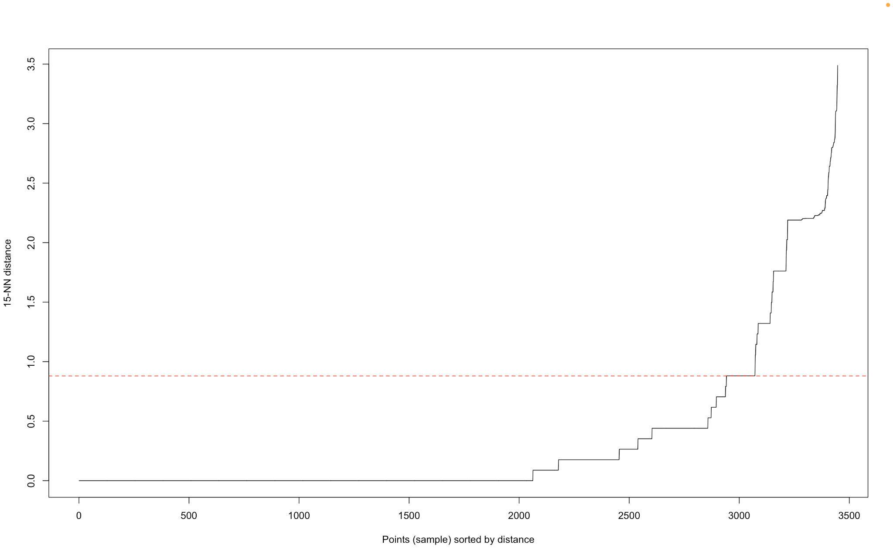

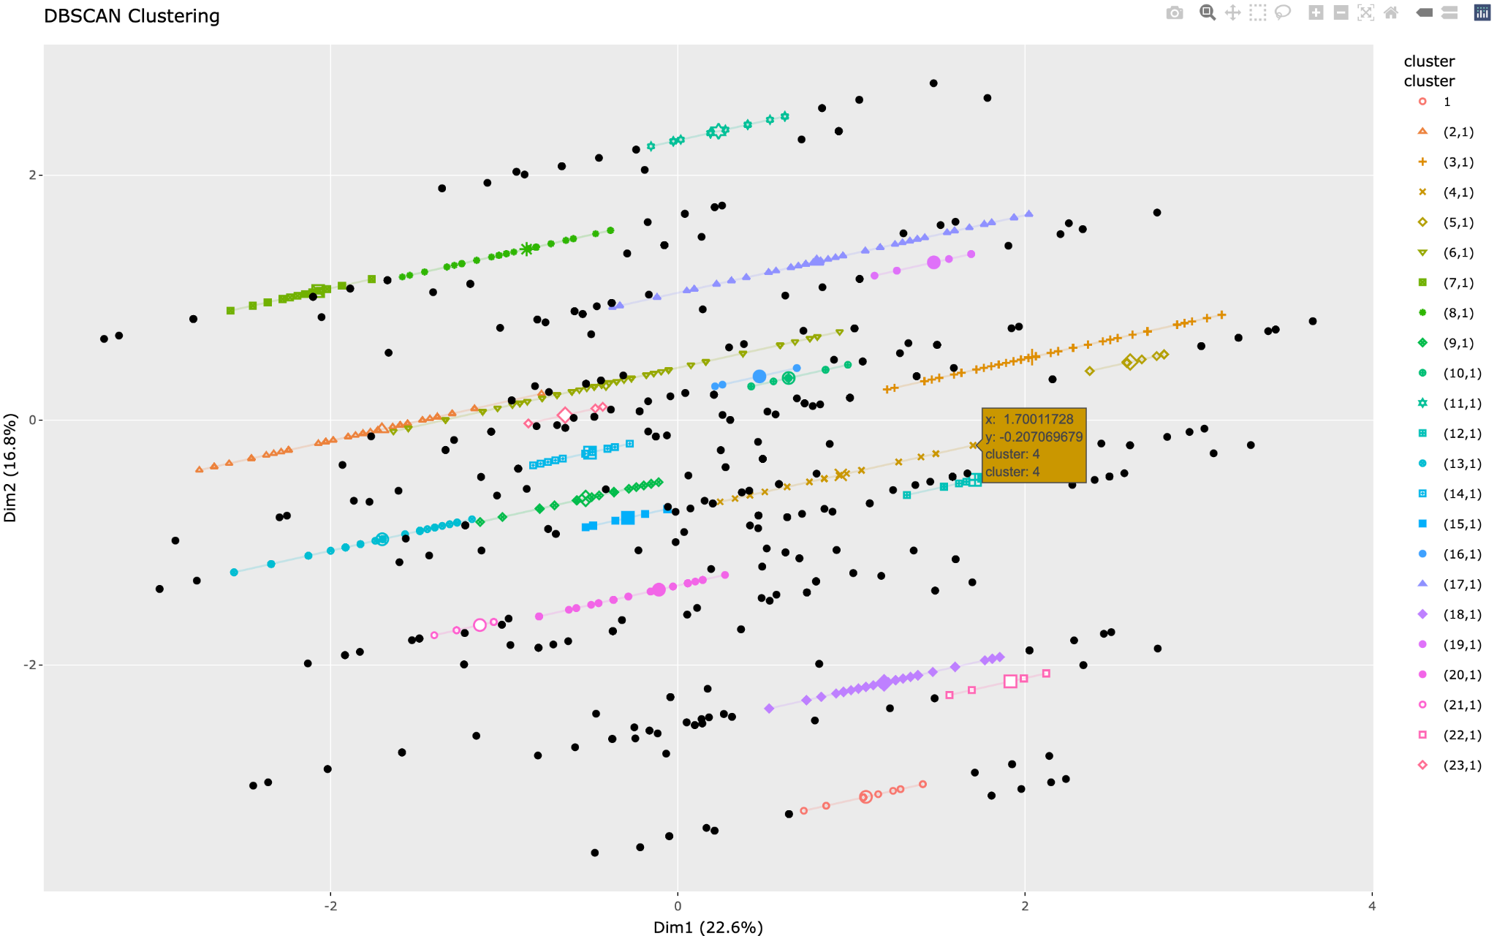

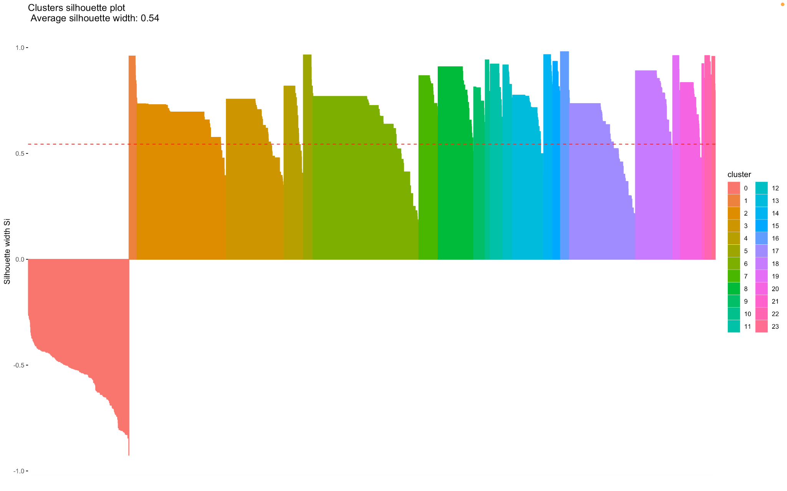

In a nutshell, It can be seen that as the number of eps points decrease the more and more valid cluster points are incorrectly being classified as noise which is not a good sign and implies that the eps value of 1.78 was the best.

Although the Davies Bouldin scores decrease, they do not work particularly well with arbitrary cluster shapes, hence silhouette scores play the most important role in determining the best eps value and hence the eps value of 1.78 is the best.

### Fuzzy-C Means

Fuzzy means has its own cluster comparison method, **Fuzziness Partition Coefficient**, the FPC provides a quantitative assessment of the fuzziness or sharpness of the clustering, a higher FPC indicates crisper, more distinct clusters.

Let’s compare for different k-values to help find the one that shows the best clusters:

#### K= 17

When k is 17, a lot of the clusters like the black and pink centers have a lot of overlap, and some of the clusters are too wide not working well to stay near each other. For k-values, FPC score is the lowest and Davies-Bouldin index is the highest. The silhouette score is also the lowest and the misclassification has a significant effect on the clusters.

FPC=0.293855

Davies-Bouldin index for Db-Scan clustering: 1.587413

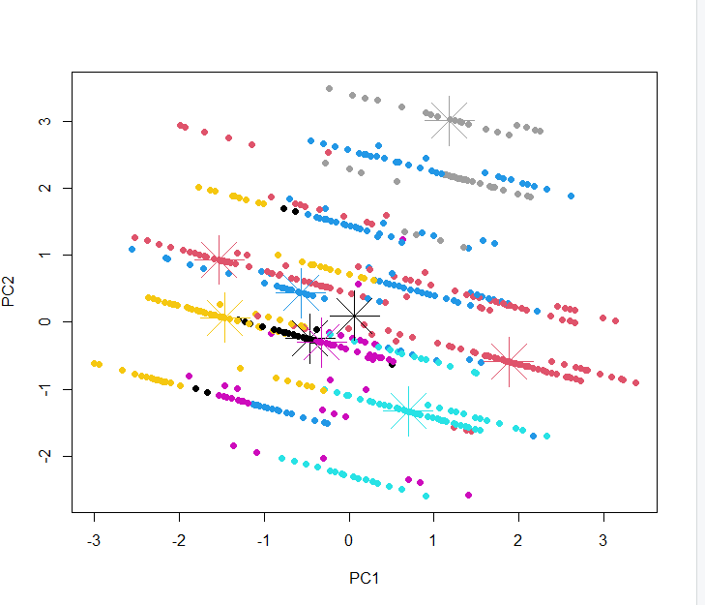

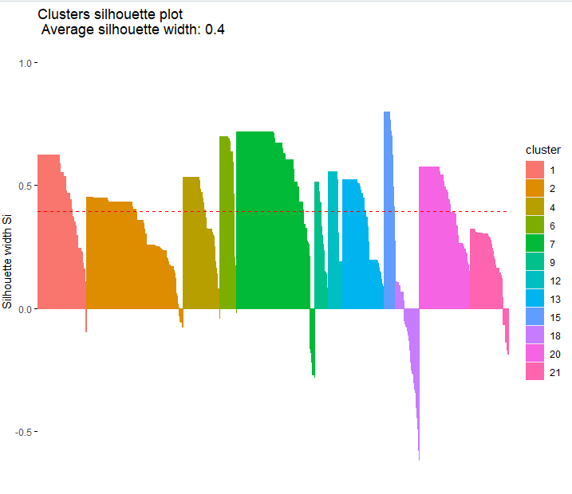

#### K = 19

While this k-value’s clusters does not have any overlapping centers, the values for some of the clusters are all over the place and are not compact and distinct like one would expect. Its silhouette plot has the least amount of misclassification and better silhouette width and height as compared to the other 2 k-values evaluated.

FPC=0.3415689

Davies-Bouldin index for Db-Scan clustering: 1.448312

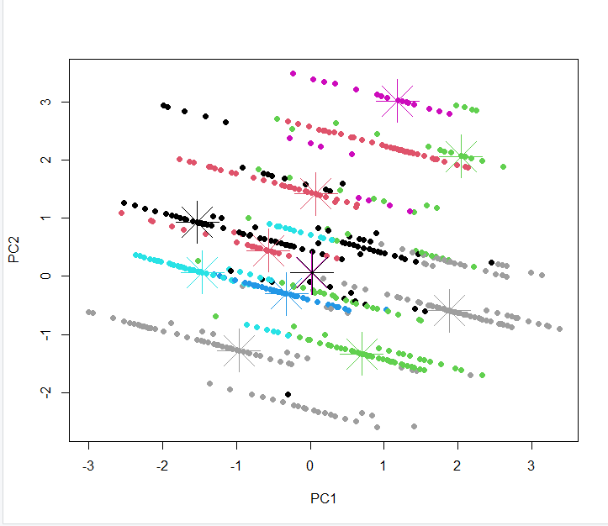

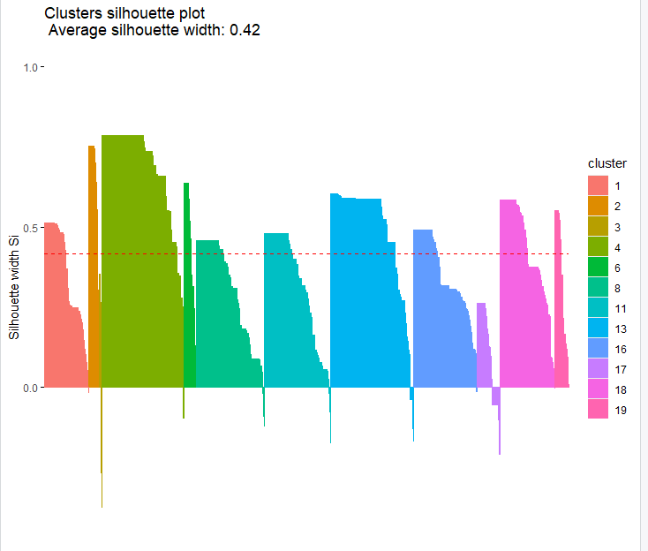

#### K= 21

This k-value has the most distinct clusters, though the misclassification is very high, the score for all evaluation methods rate this relatively high as compared to the other k-values.

FPC=0.3431432

Davies-Bouldin index for Db-Scan clustering: 1.385539

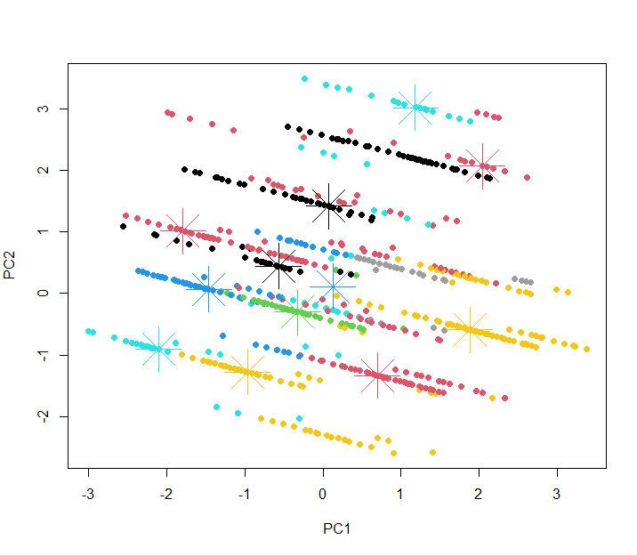

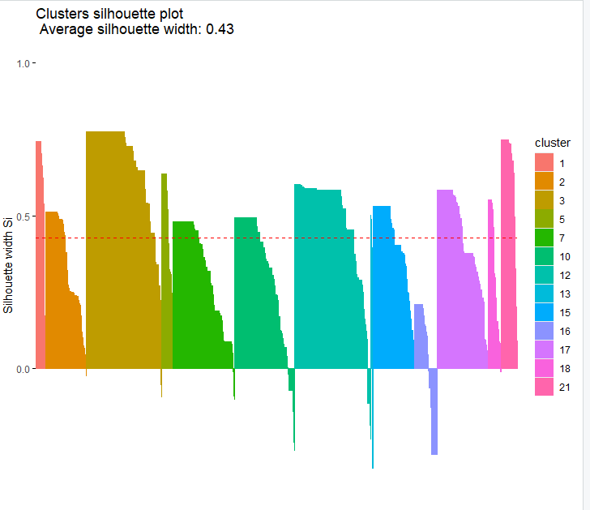

Overall K=21 shows the best evaluation scores for all the methods we used, however it does appear to contain a fair bit of misclassification as compared to k=19, however after plotting them all and based on observation and scores of all evaluation methods, we ultimately chose k=21 as the best k-value for Fuzzy c-means clustering.

## Inter-Cluster Comparison

Dealing with k-means clustering, we evaluated the quality of the clusters using different metrics with k=21 being the optimal.

Using the method for sum of squares, we observed that k=21 had a ratio of 0.833, showing great separation in the clusters.

For the silhouette analysis with k=21, we obtained an average silhouette width of 0.56, suggesting a reasonable level of cohesion and separation among the clusters.

Moreover, the Davies-Bouldin Index (DBI) revealed that k=21 performed well, with a lower DBI value indicating well-defined clusters with minimal overlap

Partitioning Around Medoids was also applied with k=21 to explore a different model and this was the optimal number for the clusters. PAM provided good clustering, mainly in dealing with noise and handling different cluster shapes. The average silhouette width for PAM was 0.56, which was identical to k-means.

DBSCAN with eps=1.78 and minPoints=16 performed the best among the different DBSCAN models, with an average silhouette width of about 0.69 and with no misclassification of points to clusters. It did really well in terms of identifying noise and identifying clusters.

Ultimately, the DBSCAN model performed the best among the different clustering models used particularly because of its ability to identify clusters of arbitrary shapes.

For Fuzzy C-means clustering k=21 showed the best scores as the FPC was the highest at 0.343, an increase of almost 0.05 as compared to to the lowest k-value and had a lowestDBI of 1.38 as well, Although its Silhouette score was the best, it did contain a ton of misclassification.

Overall, we do not recommend this method as although we pointed out k=21 had the highest intracluster score, it fell way behind other techniques such as PAM, Kmeans and DBScan, its scores for evaluation methods were by far the lowest among all and is not a good method for finding clusters on this dataset. Showing a score of 0.1 less than even the lowest of the other clustering methods for the silhouette score and DBI score was almost a whole 1 above the other clustering methods. Thus we evaluated this as the least useful method for analyzing this dataset.

# 

# Cluster Patterns

# 

Cluster 1

Characteristics: Female, earns less than 50K, divorced, and works as a professor.

Description: This cluster includes females who are divorced, earn less than 50K, and work as professors.

Analysis: This cluster is interesting because it highlights the economic disparity where divorced female professors are earning less than 50K. This could point to gender pay gaps or other systemic issues affecting earnings in academia.

Cluster 2

Characteristics: Male, married, earns more than 50K, not a professor.

Description: This cluster includes married males who earn more than 50K and are not professors.

Analysis: This pattern is reasonable as it aligns with the common observation that married males often have higher earnings, possibly due to dual-income households or higher representation in higher-paying jobs.

Cluster 3

Characteristics: Male, single, earns less than 50K, and works as a professor.

Description: This cluster includes single males who earn less than 50K and work as professors.

Analysis: This cluster is interesting as it contrasts with Cluster 2, showing that single male professors might be earning less, which could indicate that marital status influences income.

Cluster 4

Characteristics: Female, single, earns less than 50K, works less than average and is not a professor.

Description: This cluster includes single females who earn less than 50K, work less than average hours, and are not professors.

Analysis: This cluster suggests that single females might be working part-time or in lower-paying jobs. This is a reasonable pattern that aligns with observed trends of women having more part-time jobs or taking career breaks.

Cluster 5

Characteristics: Female, married, earns less than 50K, and not a professor.

Description: This cluster includes married females who earn less than 50K and are not professors.

Analysis: This is a reasonable pattern that reflects the economic reality for many married women who might be in lower-paying jobs, possibly due to family responsibilities.

Cluster 6

Characteristics: Female, single, earns less than 50K, works less than average, not a professor, and is a person of color.

Description: This cluster includes single females who earn less than 50K, work less than average hours, are not professors, and are people of color.

Analysis: This cluster highlights multiple layers of disadvantage, combining gender, marital status, race, and employment type. This is an important pattern as it points to intersecting inequalities.

Cluster 7

Characteristics: Male, married, earns less than 50K, and not a professor.

Description: This cluster includes married males who earn less than 50K and are not professors.

Analysis: This cluster is reasonable and shows that not all married males are in higher-paying jobs, reflecting economic diversity within this group.

Cluster 8

Characteristics: Male, divorced, earns less than 50K, and not a professor.

Description: This cluster includes divorced males who earn less than 50K and are not professors.

Analysis: This pattern is reasonable as it shows that divorced males might face financial difficulties or be in lower-paying jobs.

Cluster 9

Characteristics: Male, married, earns more than 50K, and is a craft repair person.

Description: This cluster includes married males who earn more than 50K and work as craft repair persons.

Analysis: This is an interesting pattern showing that some craft repair persons can earn relatively high incomes, which might be due to specialization or demand in certain areas.

Cluster 10

Characteristics: Male, married, earns less than 50K, and is a craft repair person.

Description: This cluster includes married males who earn less than 50K and work as craft repair persons.

Analysis: This is reasonable and shows economic diversity among craft repair persons.

Cluster 11

Characteristics: Male, married, earns less than 50K, and is a professor.

Description: This cluster includes married males who earn less than 50K and work as professors.

Analysis: This cluster is interesting as it suggests that not all professors earn high salaries, which could be due to different academic ranks or institutions.

Cluster 12

Characteristics: Male, single, earns less than 50K, and is a craft repair person.

Description: This cluster includes single males who earn less than 50K and work as craft repair persons.

Analysis: This is reasonable and reflects economic realities for single males in trade jobs.

Cluster 13

Characteristics: Female, single, earns less than 50K, and is a professor.

Description: This cluster includes single females who earn less than 50K and work as professors.

Analysis: This pattern is interesting as it highlights the lower earnings for single female professors, similar to Cluster 1.

Cluster 14

Characteristics: Male, married, earns more than 50K, and is a professor

Description: This cluster includes married men who earn more than 50K and work as a professor.

Analysis: This pattern can reflect societal norms where married men might be perceived as more stable or committed, potentially influencing their career advancement and earning potential in academia.

Cluster 15

Characteristics: Male, divorced, earns less than 50K, and works as a craft repair person.

Description: This cluster includes divorced males who earn less than 50K and work as craft repair persons.

Analysis: This is a reasonable pattern reflecting economic diversity among divorced males in trade jobs.

Cluster 16

Characteristics: Female, divorced, earns less than 50K, and is not a professor.

Description: This cluster includes divorced females who earn less than 50K and are not professors.

Analysis: This is reasonable and reflects economic realities for divorced females in non-academic jobs.

Cluster 17

Characteristics: Female, married, earns more than 50K, and is not a professor.

Description: This cluster includes married females who earn more than 50K and are not professors.

Analysis: This is an interesting pattern showing that some married females can earn high incomes in non-academic roles.

Cluster 18

Characteristics: Male, married, earns less than 50K, and not a professor.

Description: This cluster includes married males who earn less than 50K and are not professors.

Analysis: This pattern is reasonable and similar to Cluster 7.

Cluster 19

Characteristics: Male, single, earns less than 50K, and is not a professor.

Description: This cluster includes single males who earn less than 50K and are not professors.

Analysis: This is reasonable and shows economic diversity among single males in non-academic jobs.

Cluster 20

Characteristics: Male, single, earns less than 50K, is not a professor, and is a person of color.

Description: This cluster includes single males who earn less than 50K, are not professors, and are people of color.

Analysis: This cluster highlights multiple layers of disadvantage, combining gender, marital status, race, and employment type, similar to Cluster 6.

Cluster 21

Characteristics: Female, married, earns more than 50K, is a professor.

Description: This cluster includes married females who earn more than 50K and work as professors.

Analysis: This is an interesting pattern showing that married female professors can earn high incomes, which contrasts with some other clusters.

Cluster 22

Characteristics: Male, divorced, earns more than 50K, works more hours per week than average, and is not a professor.

Description: This cluster includes divorced males who earn more than 50K, work more hours per week than average, and are not professors.

Analysis: This pattern is reasonable and shows economic diversity among divorced males who work more hours.

Cluster 23

Characteristics: Female, divorced, earns less than 50K, is not a professor, and is a person of color.

Description: This cluster includes divorced females who earn less than 50K, are not professors, and are people of color.

Analysis: This cluster highlights multiple layers of disadvantage, similar to Clusters 6 and 19.

Cluster 24

Characteristics: Male, married, earns more than 50K, is not a professor, and is a person of color.

Description: This cluster includes married males who earn more than 50K, are not professors, and are people of color.

Analysis: This pattern is interesting as it shows that married males of color can earn high incomes in non-academic roles.

Cluster 25

Characteristics: Female, divorced, earns more than 50K, works more than average, and is not a professor.

Description: This cluster includes divorced females who earn more than 50K, work more hours than average, and are not professors.

Analysis: This is an interesting pattern showing that divorced females can earn high incomes and work more hours in non-academic roles.

Cluster 26

Characteristics: Female, married, earns less than 50K, is not a professor, and is a person of color.

Description: This cluster includes married females who earn less than 50K, are not professors, and are people of color.

Analysis: This cluster highlights multiple layers of disadvantage for married females of color in non-academic roles.

The above cluster characteristics, description, and analysis suggest that there is probably some pattern in race and income the people earn,

The following is a plot of race and income

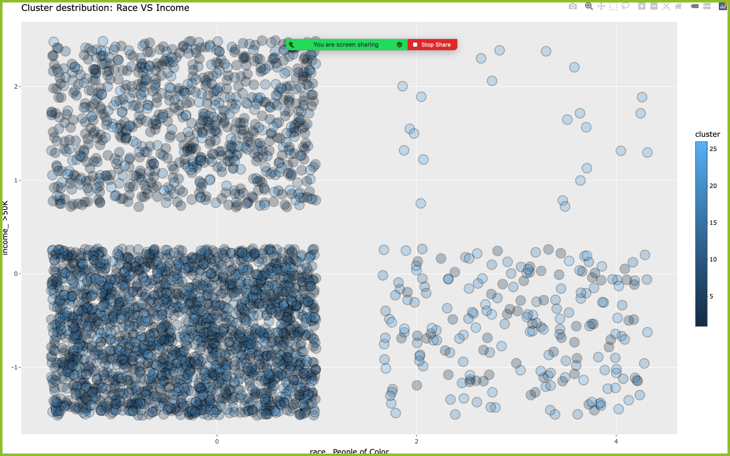

It can be seen that people belonging to other races than White, have lesser chances of earning higher incomes, whereas people who belong to the White race have greater chances of earning higher incomes.

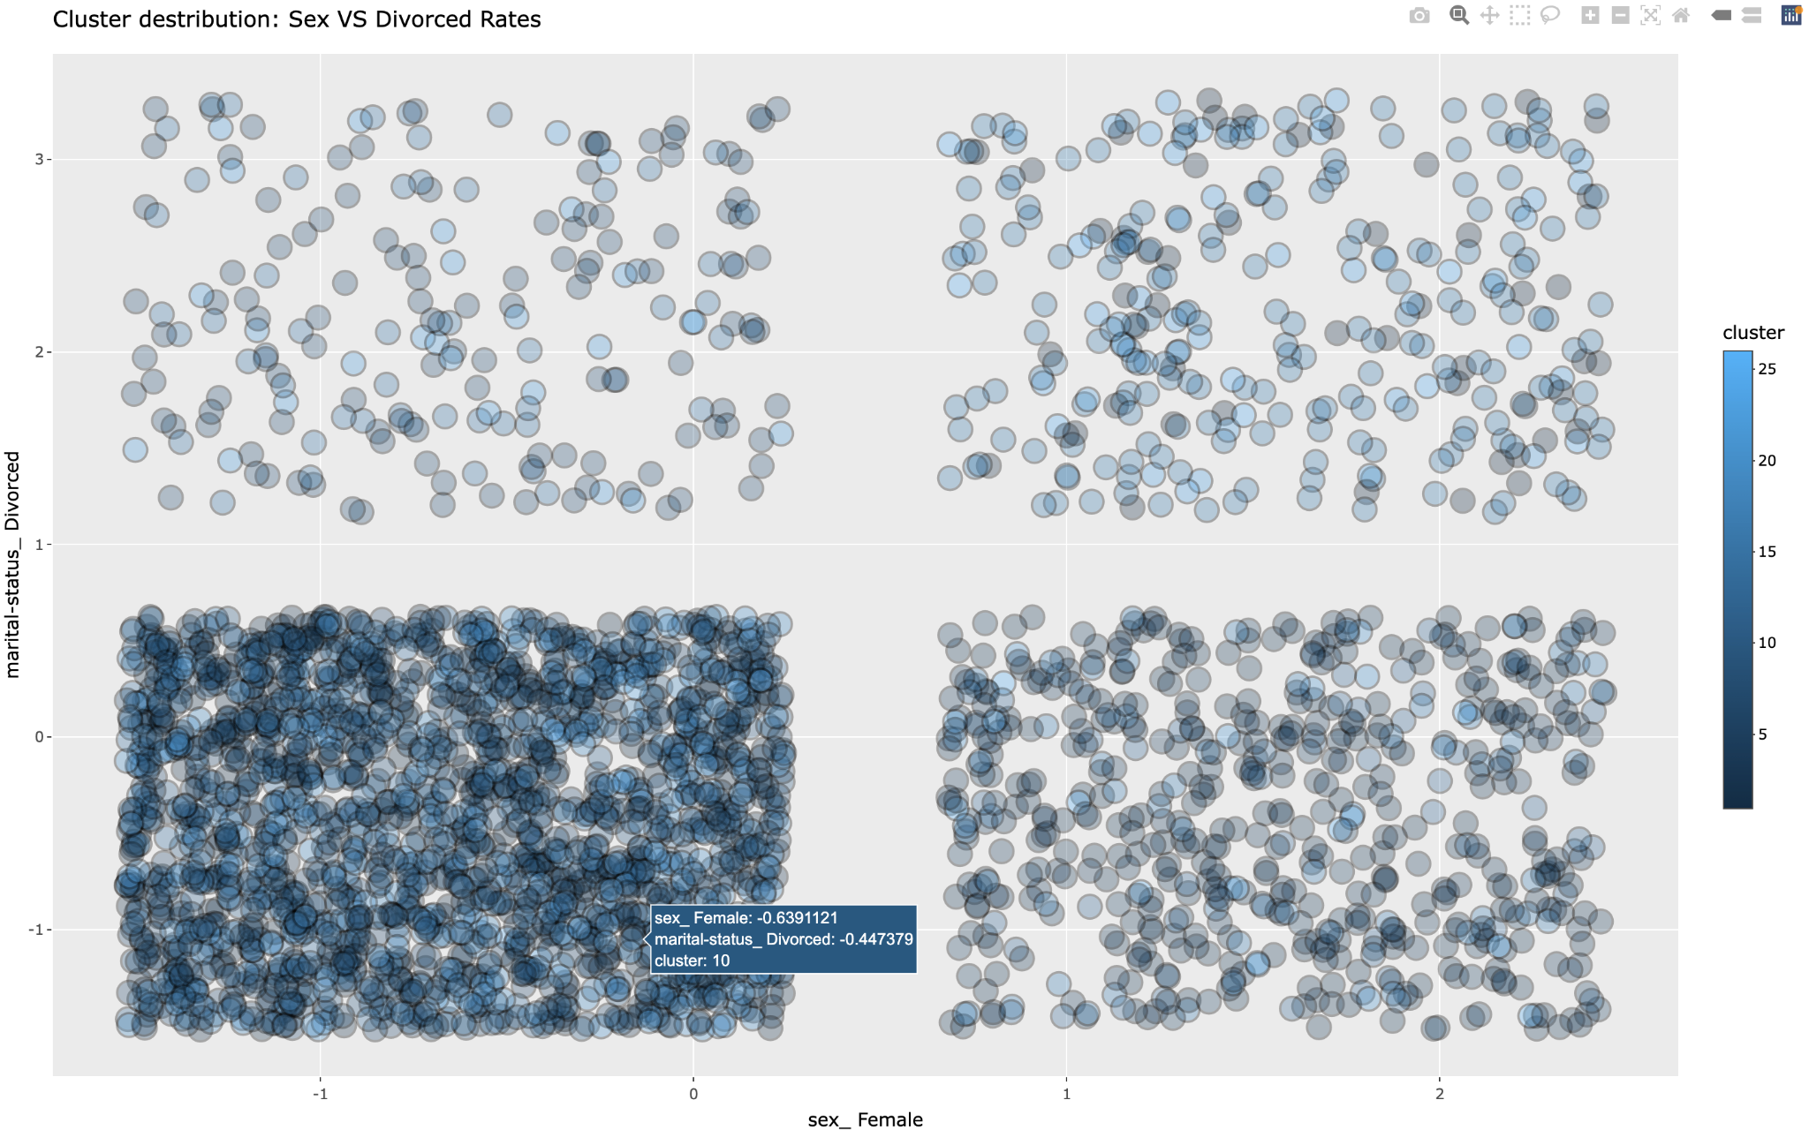

From the above graph it can be inferred that in general males tend to have lower divorce rates as compared to females.

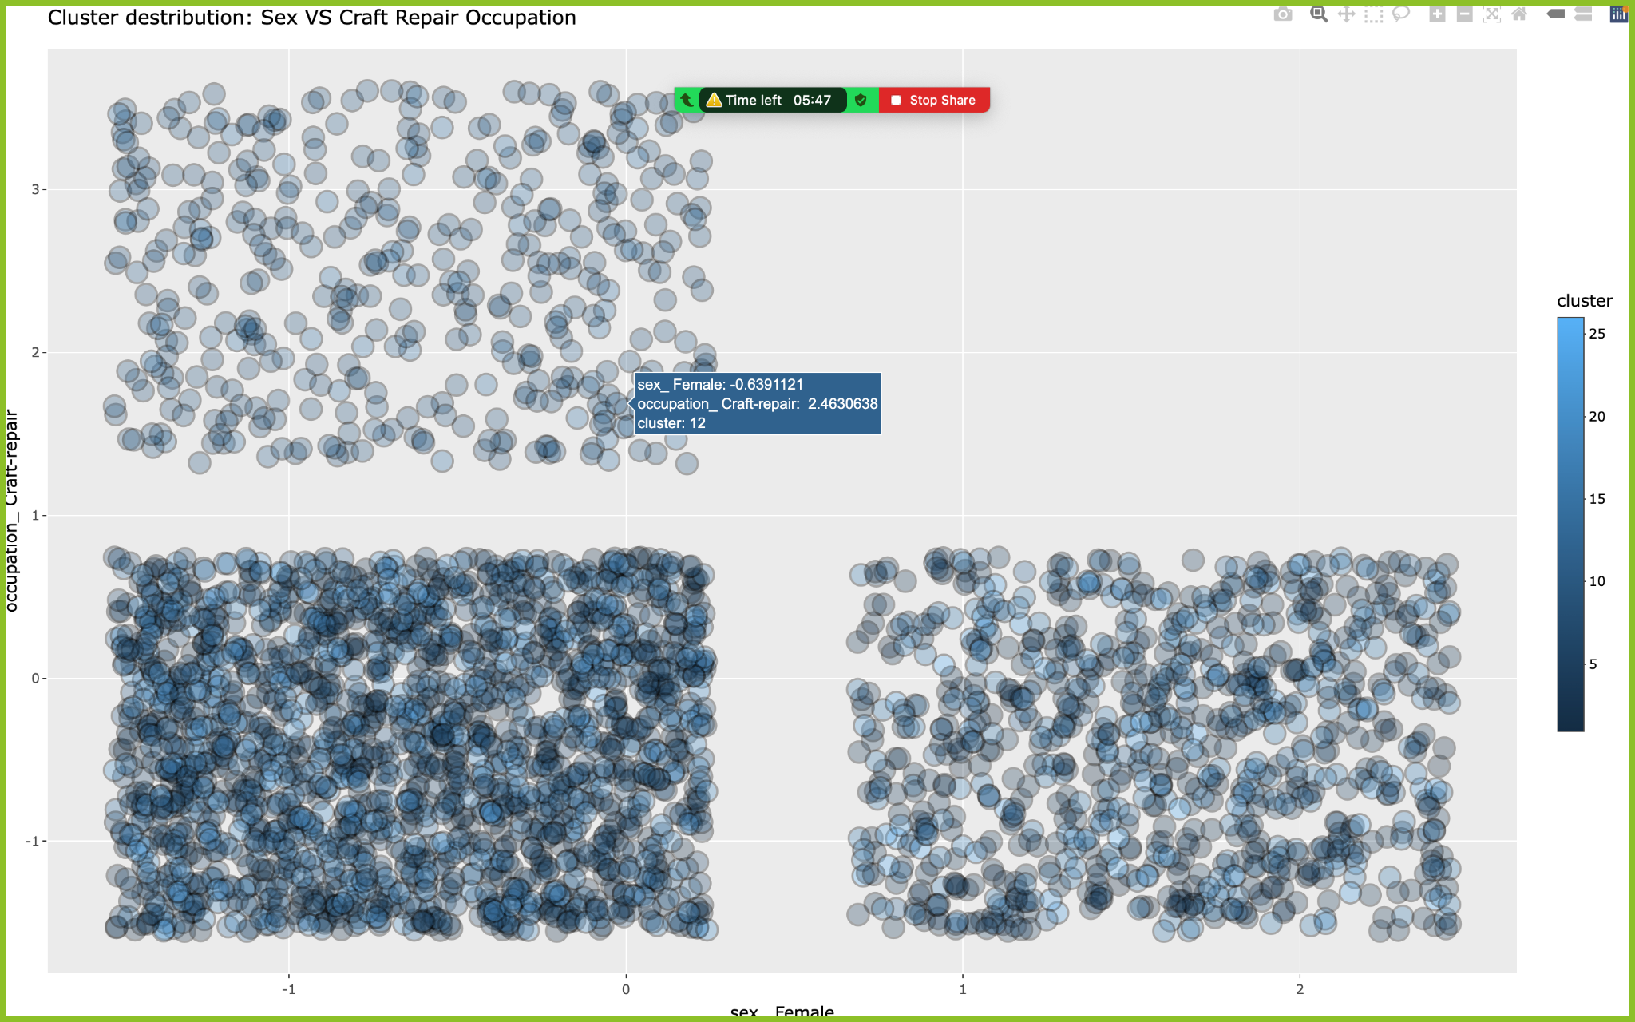

For the above graph it can be seen that females are not usually engaged in occupations such as crafts and repair indicating societal biases or barriers that prevent females from entering certain occupations.

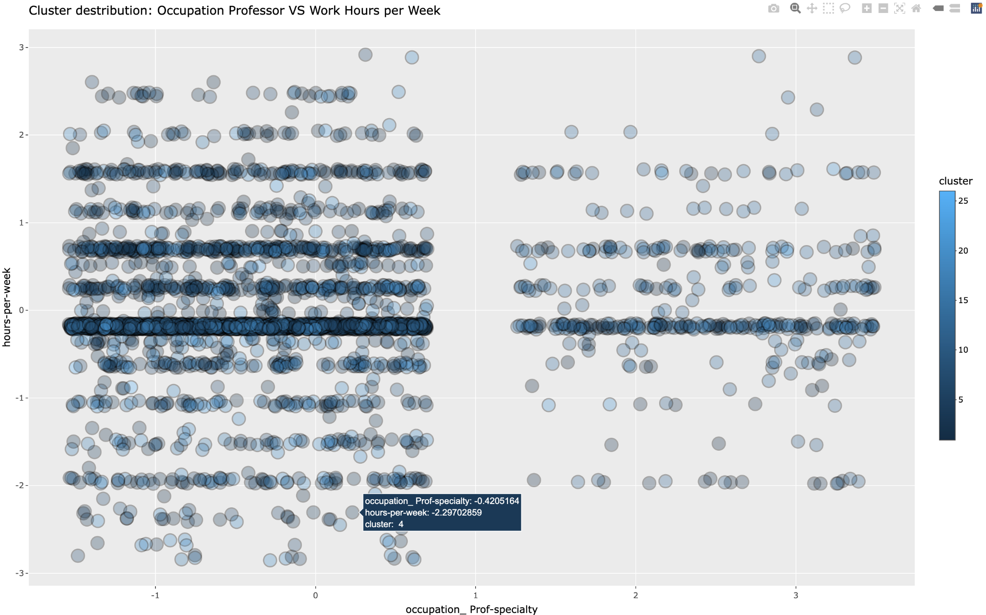

From the above graph it can be seen that people who work as professors in general work lesser hours per week as compared to other professions.

In conclusion, the clustering analysis reveals several discernible patterns across different demographic and occupational groups. There is a noticeable income disparity between racial groups, with individuals of White ethnicity generally having a higher likelihood of earning higher incomes compared to other racial groups. Gender disparities are also evident, with males showing lower divorce rates and being more engaged in certain occupations like crafts and repair, while females are less likely to be involved in these fields, potentially indicating societal biases or barriers. Professors, as a profession, tend to work fewer hours per week compared to other occupations, which aligns with expectations within academia. These patterns highlight the complex interplay of factors such as race, gender, and occupation in shaping socio-economic outcomes and underscore the need for further investigation into the underlying causes and implications of these trends. These results could also have been impacted by the inherent bias in the dataset towards some classes.

# 

# Conclusion

In conclusion, this report took the reader through the variety of steps entailed in the clustering and analysis.

The introductory segment dealt with preprocessing, which involved an initial examination of data, looking at the kinds of features, and their unique values, and identifying missing and not so useful features. This was followed by an in depth graphical analysis, which involved looking at the distribution of numerical features via a histogram, and the distribution of income among the people belonging to different classes, along with the scrutiny of categorical and ordinal features via a bar plot and the subsequent distribution of income. These graphs revealed key insights about the distribution of the underlying data, helped combine various classes, assisted in making key decisions regarding feature selection and dealing with outliers, and finally provided useful information about not so important features.

This was followed by data transformation which entailed a variety of techniques, such as one hot encoding, dropping most frequent dummy columns, sampling, standard scaling, Random Forests, dealing with outliers, and ultimately, Principal Component Analysis (PCA).

The second section discussed the variety of clustering methods explored in a bid to identify the most suitable clustering technique, including, k-means, partition around medoids, Density-Based Spatial Clustering of Applications with Noise, and Fuzzy c-means clustering techniques. The optimal number of clusters for techniques like k means were determined using a variety of techniques like within cluster sum of squares, gap statistic, silhouette scores, ratio of between sum of squares to total sum of squares, and visualizing the dendrogram.

The third segment took a deep dive into comparison of quality parameters among different models and comparison of the same model with different key parameters. The quality parameters that were relied on primarily were Silhouette Scores and the Davies Bouldin Index. In addition the silhouette widths were also visualized to gain a deeper understanding of the accuracy and quality of different clustering techniques, and identify any misclassification of points to clusters. It was found that DBSCAN emerged the best clustering technique for the dataset under discussion, given the non-convex shapes of clusters, and the inability of techniques like k-means to handle non-convex clusters.

Finally, the fourth section, involved analyzing the characteristics of the different clusters identified by the best clustering algorithm for the given dataset, that is DBSCAN. The centers were identified, exported in the form of an excel sheet, and their characteristics established. Some interesting patterns were also identified and have been documented.